Change Requests for Blanket Orders are slightly different than for Non-Catalog Orders and here are some helpful hints.
- You can only add additional funds not request a new line to an existing blanket order
- If you need a new line created, you will need to contact your local business office
- If a new line is needed for a blanket order, you will need to contact purchasing at the business office to add a line
- Always add a comment to explain as an internal note so that purchasing and the department approver and purchasing will understand the change
- The change request does go back through workflow to the cost center approver(s) and if over $100,000, will go to the vice chancellor for approval.
- Attach any additional documentation for purchasing and if over $100,000, for the vice chancellor
- If you need to close the purchase oder, contact your local business office and do not use a change request
- YOU DO NOT HAVE THE ABILITY TO CREATE A CHANGE REQUEST ON A FULLY INVOICED PO

Select Create Change Request in Available Actions and click Go:

Create Change Request screen will appear. You may select a user or click the add email recipient to include more users. The email recipients will automatically receive a system email with the change order text configured in the next field. Enter a description of the change in the text field and click Create Change Request:

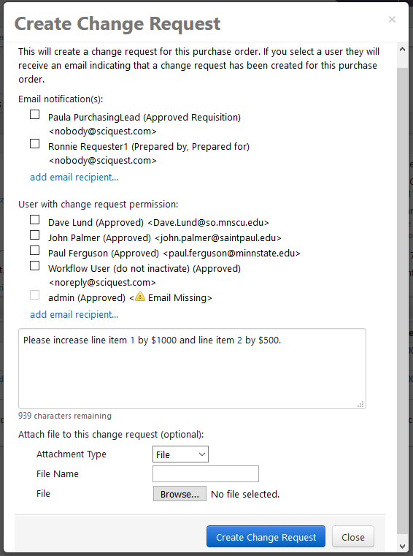

On the top left of the page it will say Change Request. Items that are changeable on a PO include line items, accounting codes, billing information and shipping information.
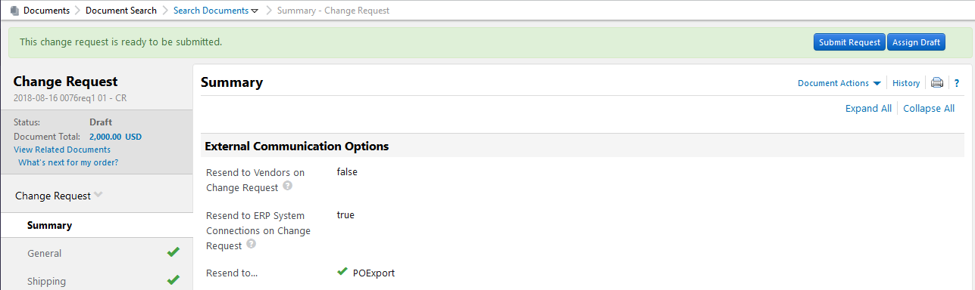

Scroll down to the line-level and select Supplies for FY 19 or Detailed Edit.

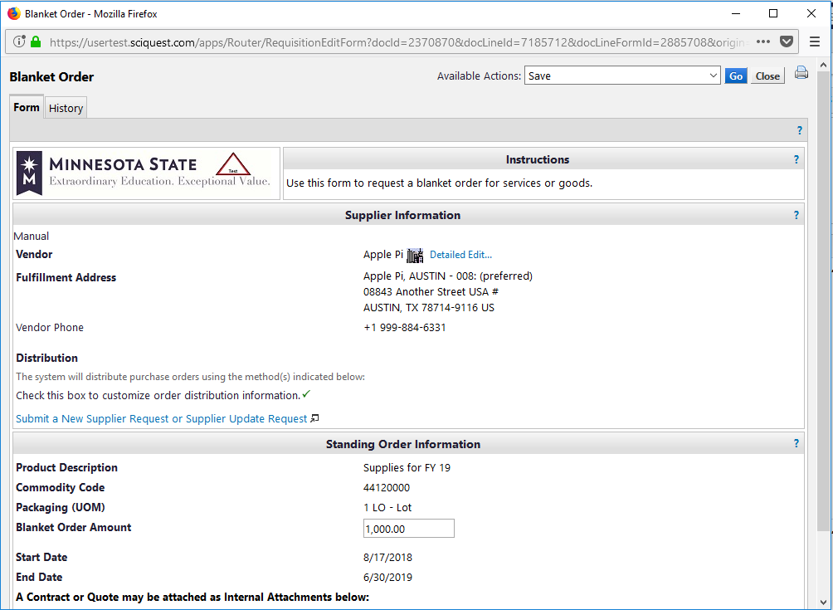
Please adjust the dollar amount in the Blanket Order Amount section. Click Go. After the changes have been saved click Close.

The Ext. Price for line item 1 is now $2,000.
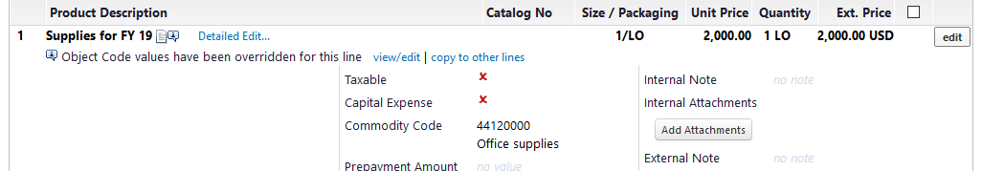

Click Advertisement for FY 19 or Detailed Edit

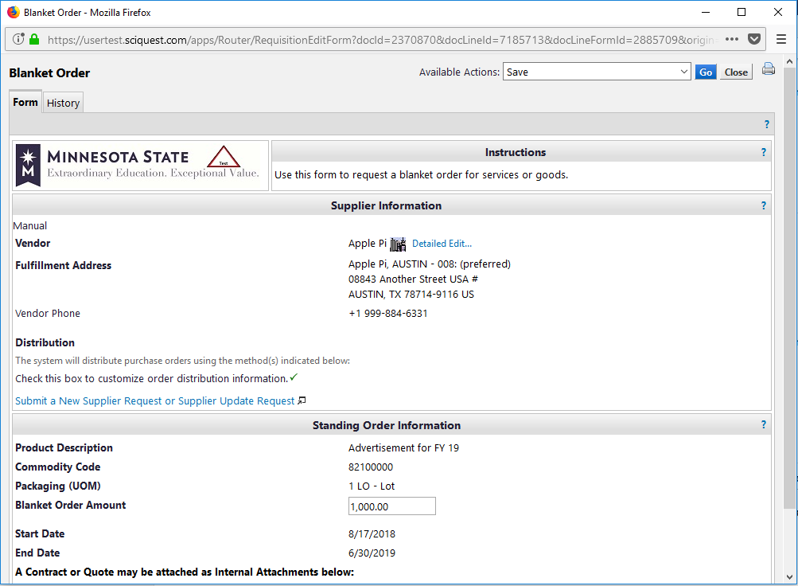
Please adjust the dollar amount in the Blanket Order Amount section. Click Go. After the changes have been saved click Close.

The Ext. Price for line item 2 is now $1,500.
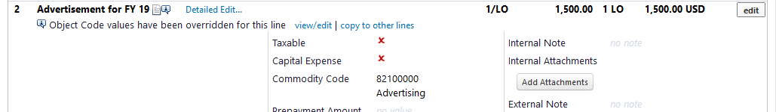

You can also go into the original cart and make adjustments by clicking on detailed edit or the blanket order icon.
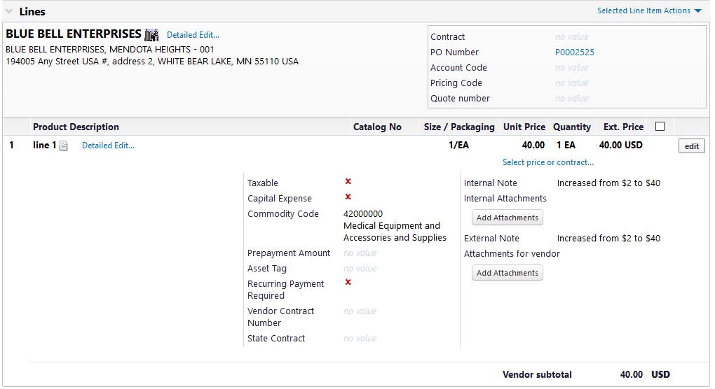

At the cart you can make adjustments and always remember to click save.
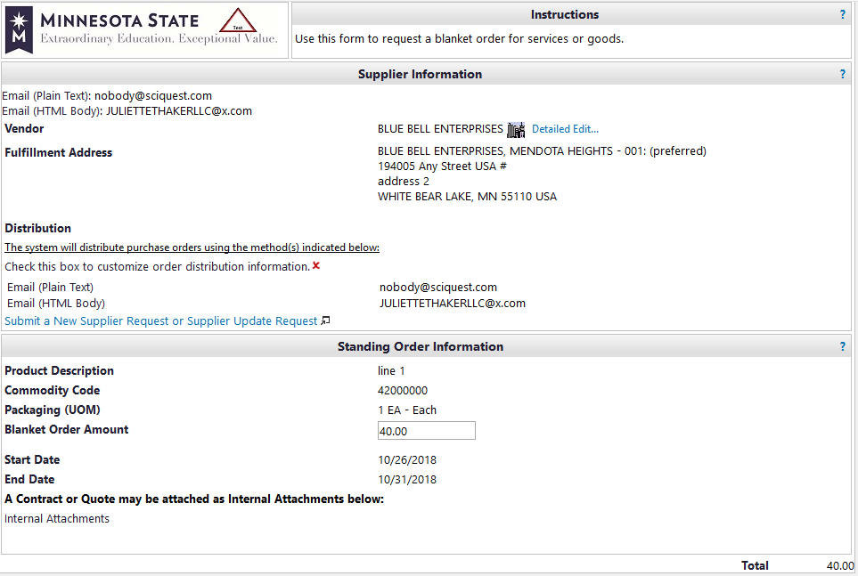

For each line adjusted add an internal note so that purchasing/buyer and department approver can quickly see what the change was to the original Purchase Order by clicking edit at the line level of the of the Change Request Summary.

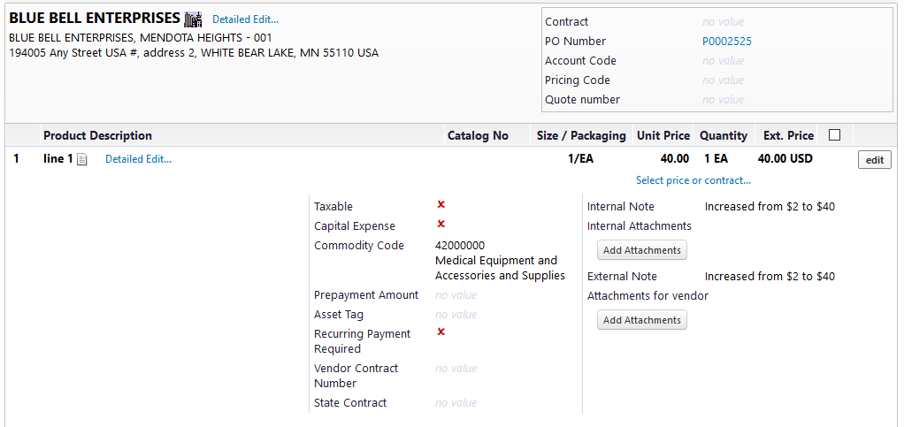

Enter description of quantity/amount from original Purchase Order and Change Request and click save.
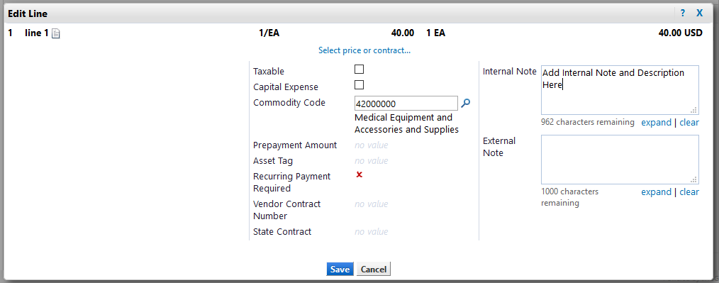

Scroll to the top of the page and click Submit Request.
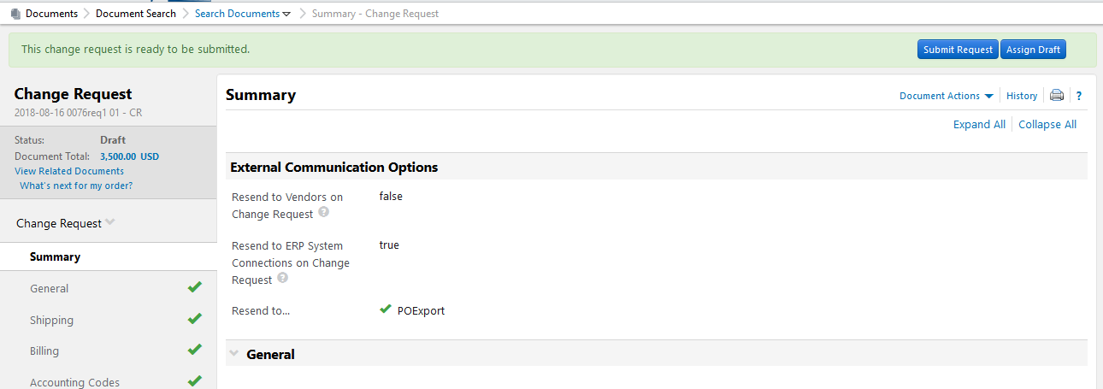

A Change Request number has been created. Click View Approval Status to view the Pending Review Approvals workflow.
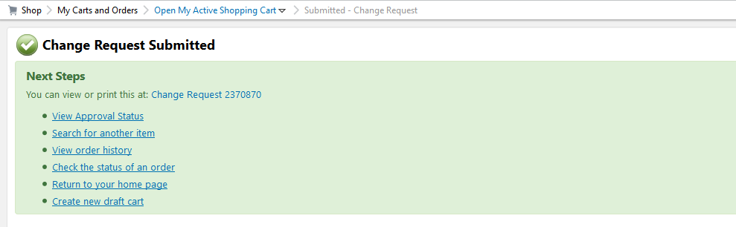

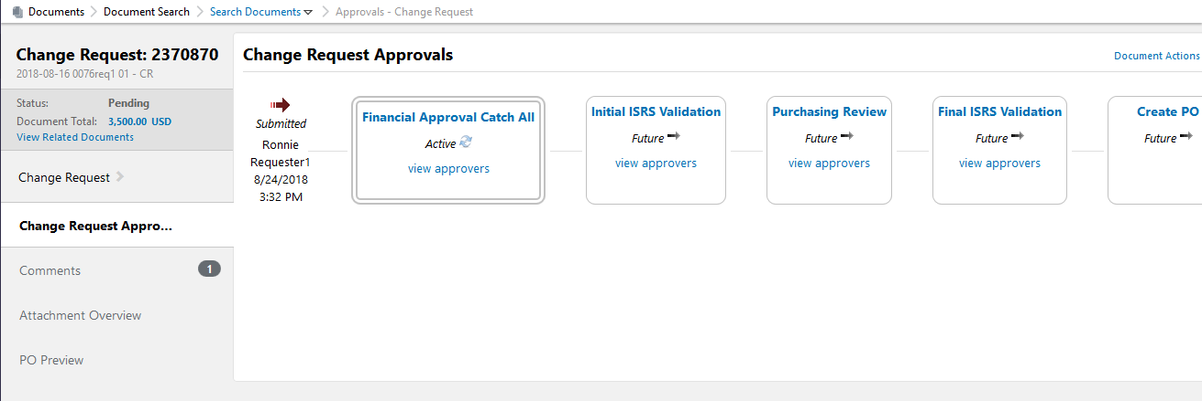

When the Change Request Workflow is at the Department Approver, see Change Requests in their action items. REMEMBER TO ASSING TO YOURSELF if you are going to edit the document.

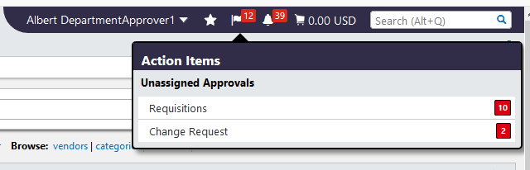

Click the Change Request No.
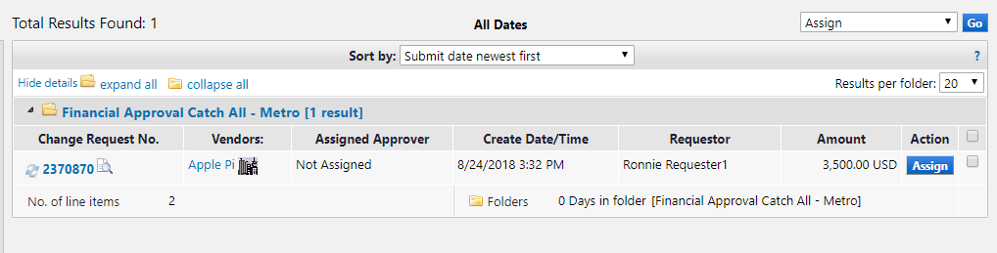

Review the requisition and select Approve/complete step under Document Actions.
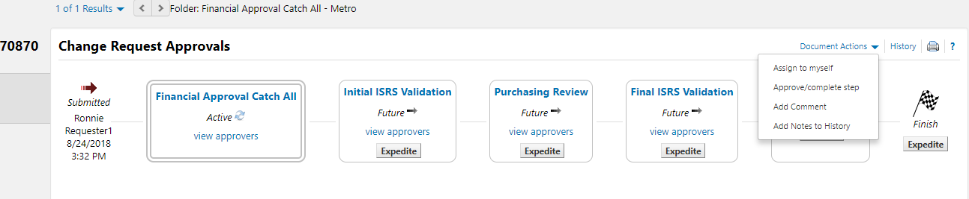

Click Change Request.

When the Change Request Workflow is at Purchasing, Purchasing will see Change Requests in their action items.

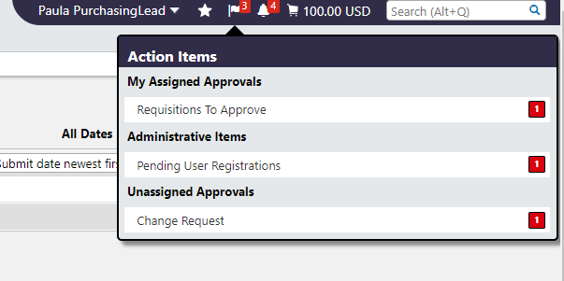
Click the Change Request No.
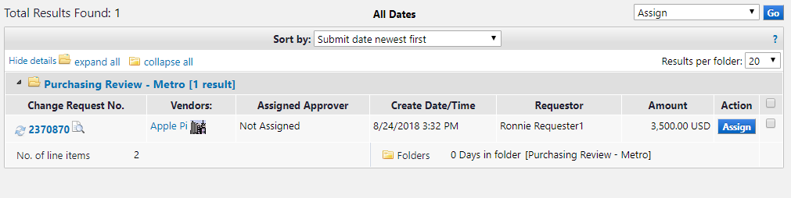

Prior to Approving, Purchasing MUST determine distribution and sending to the ERP by selecting edit under available actions. Only purchasing has the ability to modify distribution and sending to the ERP in Change Request Workflow.

To Approve, select Approve/complete step under Document Actions.

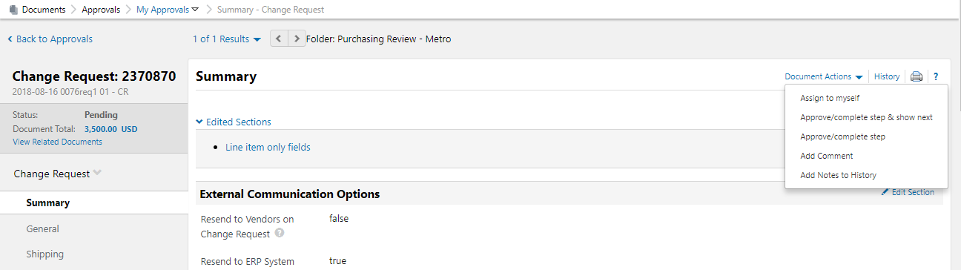

If there are no pending Change Request you will receive a No Documents found message.

The requested increase will export to ISRS.
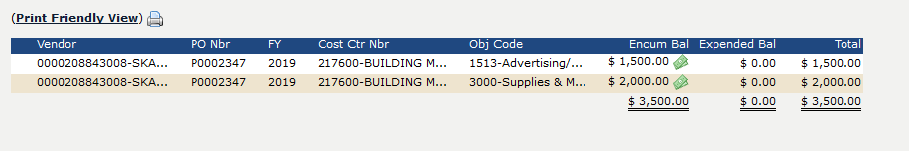

SPECIAL NOTE
Any returned, returned or draft change requests can be found at the purchase order at the change request tab.

