Change Request For Non-Catalog Orders

Here are some helpful hints Change Requests Non-Catalog Orders and.
- You can add an additional line to a Non-Catalog Order
  - Please verify you have added an object code, cost center and commodity code
- Always add a comment to explain as an internal note so that purchasing and the department approver and purchasing will understand the change
- The change request does go back through workflow to the cost center approver(s) and if over $100,000, will go to the vice chancellor for approval.
- Attach any additional documentation for purchasing and if over $100,000, for the vice chancellor
- If you need to close the purchase oder, contact your local business office and do not use a change request
- YOU DO NOT HAVE THE ABILITY TO CREATE A CHANGE REQUEST ON A FULLY INVOICED PO

Please submit a Change Request to request changes to a PO. Note you cannot change the vendor for a completed PO. Please search for the PO you wish to change in Marketplace and follow the directions below:

In Available Actions select Create Change Request and click Go:

Select a user or click the add email recipient to include more users. The email recipients will automatically receive a system email with the change order text configured in the next field. Enter a description of the change in the text field and click Create Change Request:
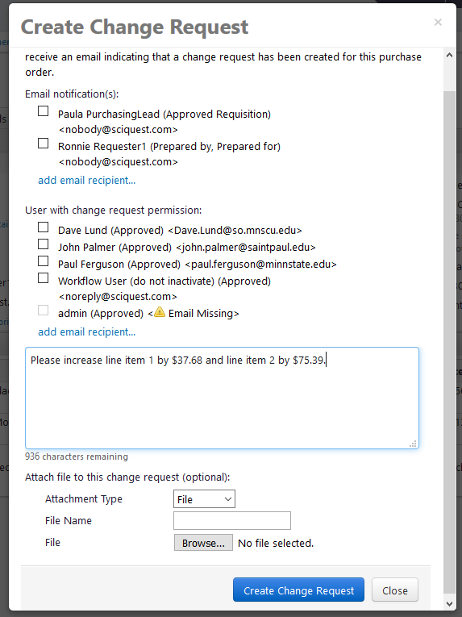

On the top left of the page the requisition will say Change Request. Items that are changeable on a PO include line items, accounting codes, billing information and shipping information.
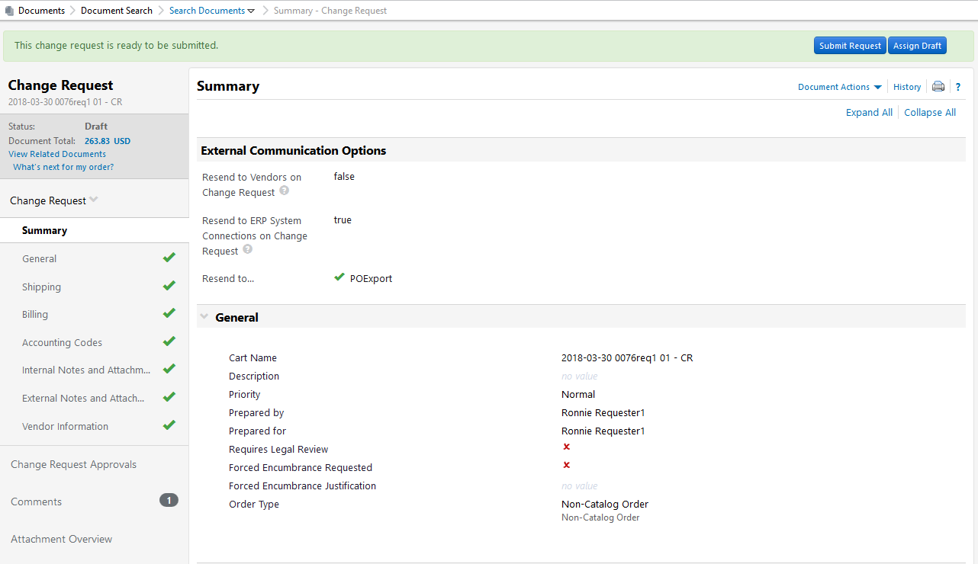

Scroll down to Lines. Under Lines you will see the Product Description. You can increase the dollar amount at the line level by selecting edit for each line item. (Note if you’d like to add an additional line item click Add non-catalog item for this vendor):
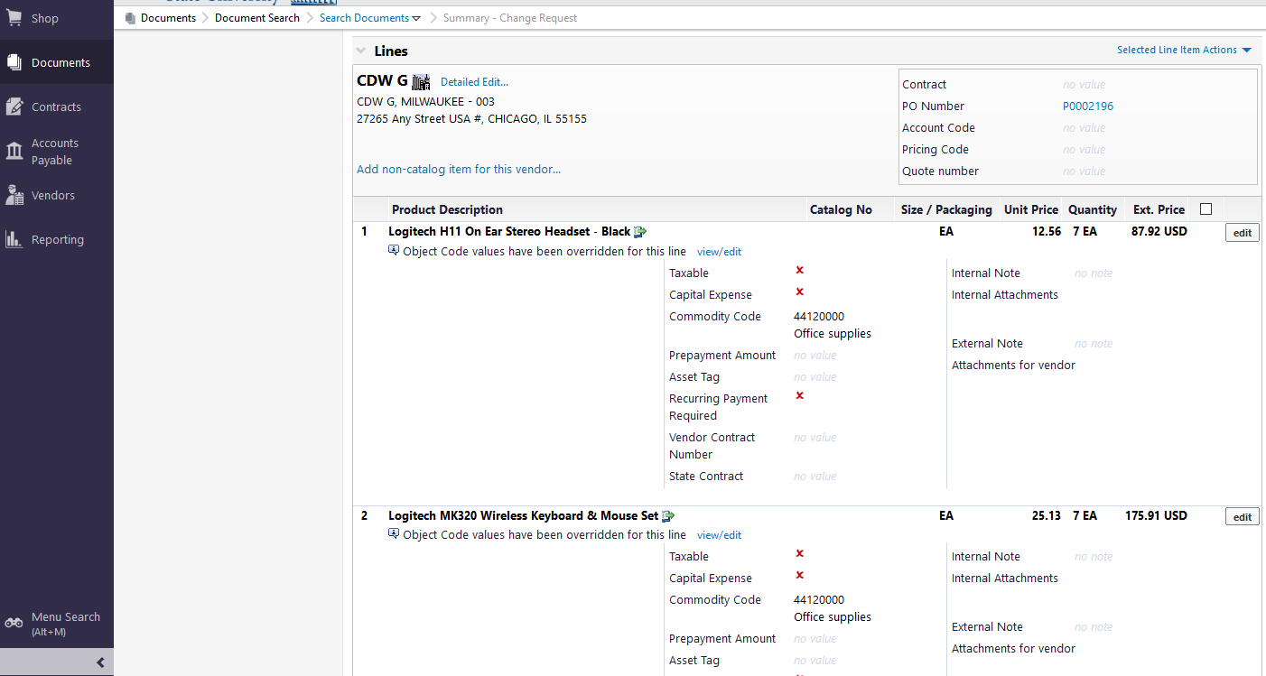

Change the Quantity for line item 1 from 7 to 10 to request an increase of $37.68. Click Save:
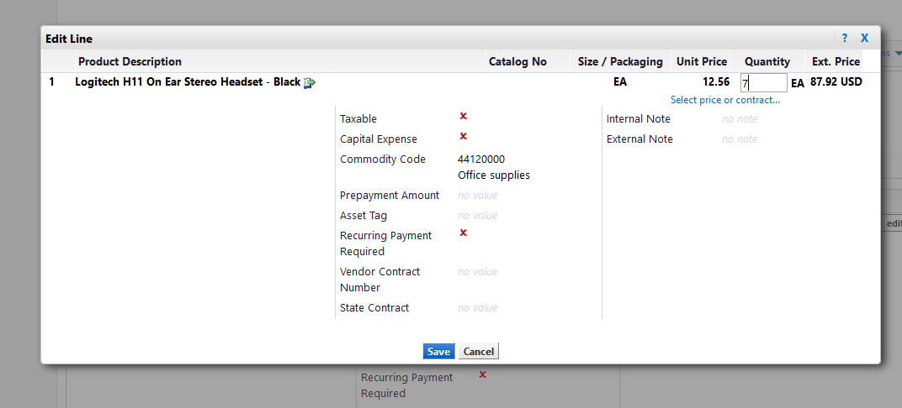

The dollar amount for line item 1 will change from $87.92 to $125.60:
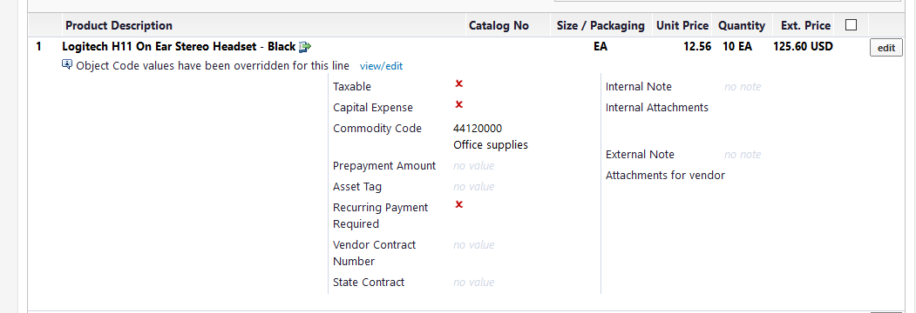

Click edit for line item 2:

Change the Quantity for line item 2 from 7 to 10 to request an increase of $75.39. Click Save:
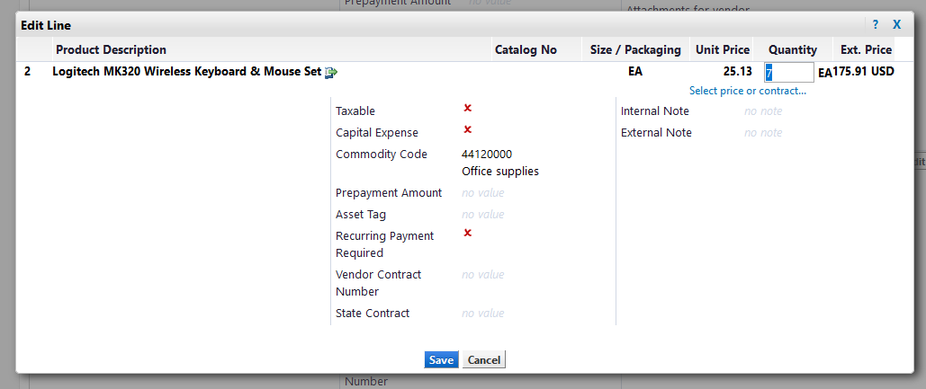

The dollar amount for line item 2 will change from $175.91 to $251.30:
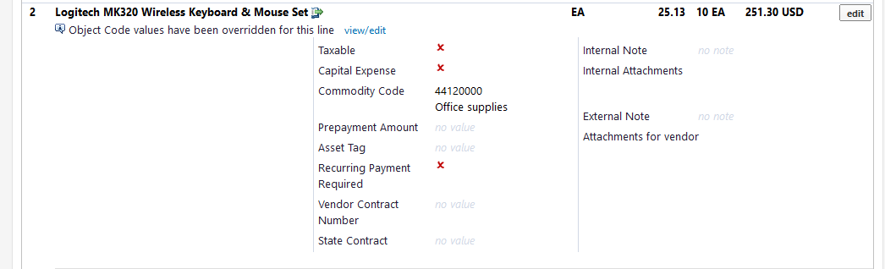

You can also go into the original cart and make adjustments by clicking on detailed edit or the non-catalog icon.

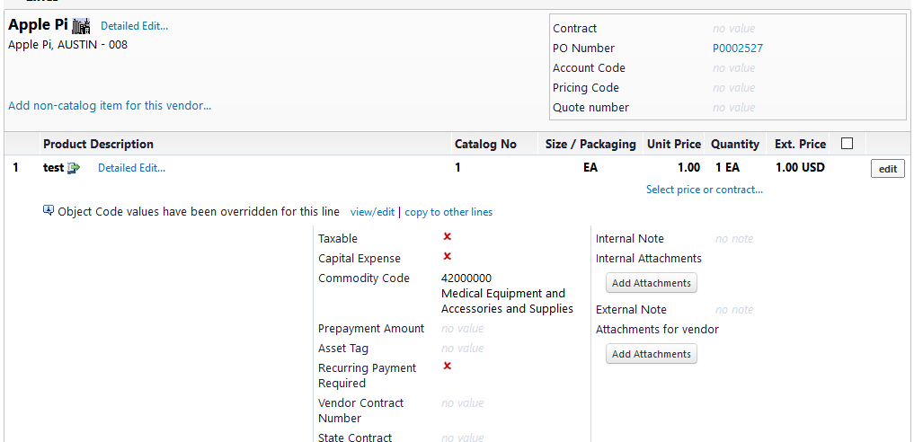

At the cart you can make adjustments and always remember to click save.

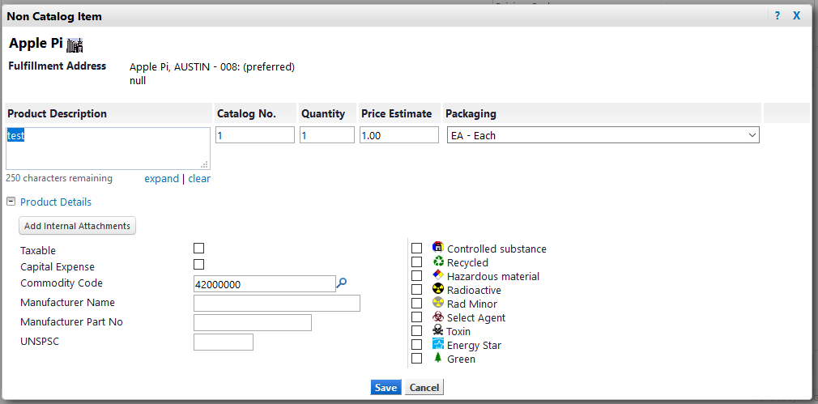
For each line adjusted add an internal note so that purchasing/buyer and department approver can quickly see what the change was to the original Purchase Order by clicking edit at the line level of the of the Change Request Summary.
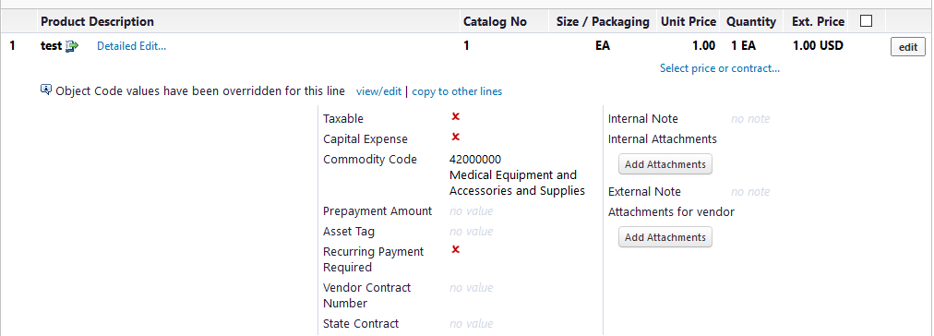

Enter description of quantity/amount from original Purchase Order and Change Request and click save.
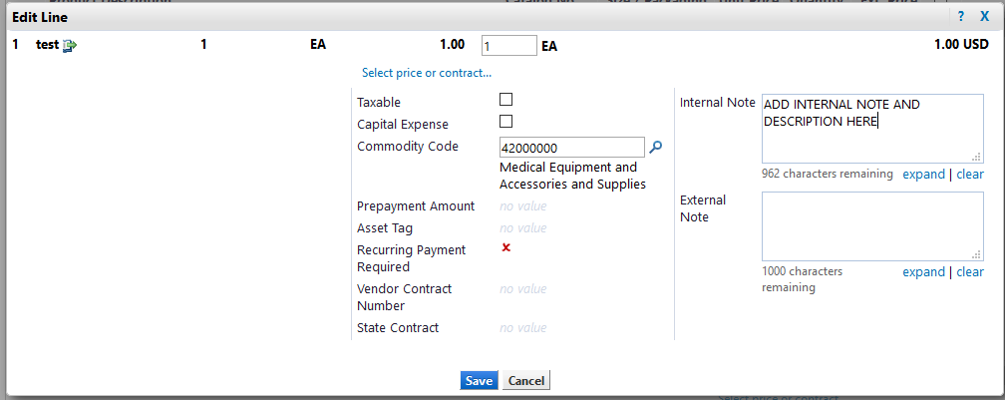

Scroll to the top of the page and click Submit Request:

A Change Request number has been created. Click View Approval Status to view the workflow:
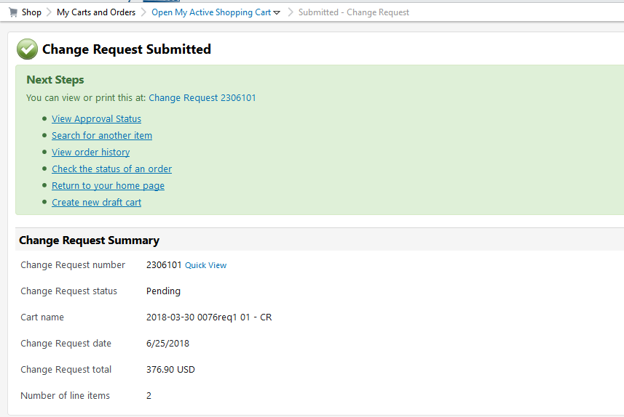

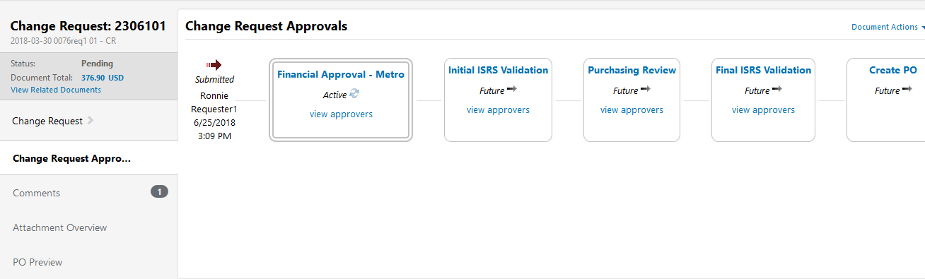

When the Change Request Workflow is at the Department Approver, see Change Requests in their action items. REMEMBER TO ASSING TO YOURSELF if you are going to edit the document.

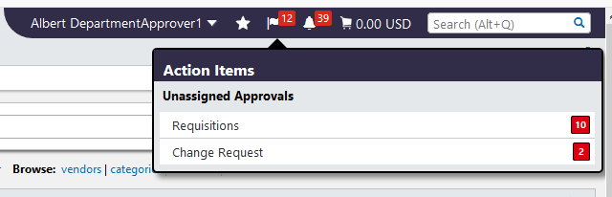

Click the Change Request No.
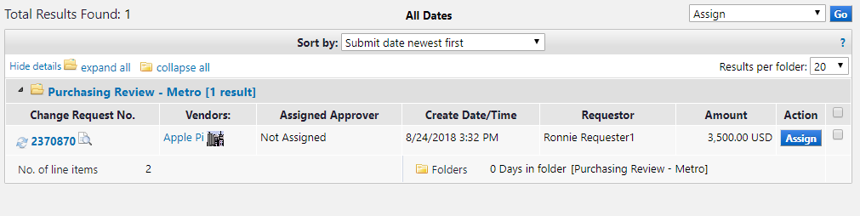

After reviewing the Change Request, the Department Approver can approve the Change Request

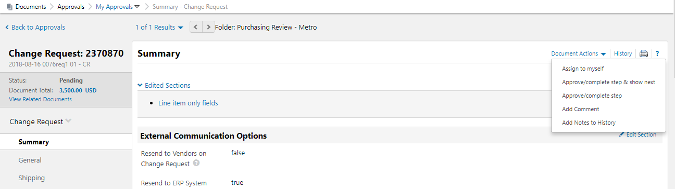

Once Approved, the workflow will move to Purchasing Review
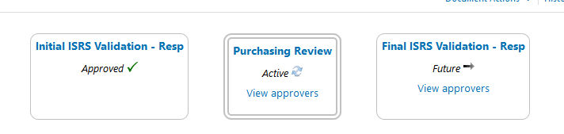

When the Change Request Workflow is at Purchasing, Purchasing will see Change Requests in their action items.

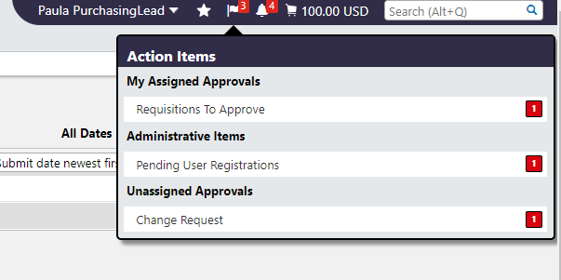
Click the Change Request No.

Prior to Approving, Purchasing MUST determine distribution and sending to the ERP by selecting edit under available actions. Only purchasing has the ability to modify distribution and sending to the ERP in Change Request Workflow.

To Approve, select Approve/complete step under Document Actions.

If there are no pending Change Request you will receive a No Documents found message.

SPECIAL NOTE
Any returned, returned or draft change requests can be found at the purchase order at the change request tab.

