RECEIPTING MARKETPLACE ORDERS / SERVICES

Types of “Orders”
- Goods purchased through catalog orders (punch-out order)
- Goods purchased or services received through non-catalog purchase orders
- Services received or goods purchased through blanket orders
Two types of receipting:
- Quantity Receipt – Orders for goods received will require the user / shopper to confirm the date goods were received and the quantity received as a Quantity Receipt. (Example: office supplies)

- Cost Receipt – Orders for services received require the user / shopper to enter in the dollar amount of the service received as well as the date services were rendered as a Cost Receipt. (Example: Contracts & ALL blanket orders)

PREPARING to create an electronic receipt:
- Determine which type of receipt you will be creating & the number of receipts to be completed:
Quantity (goods – catalog & non-catalog)
Cost (services / blanket orders)

- Supporting Documentation:
Packing Slip / Invoice or equivalent document** – the following information is REQUIRED to be on your document
- PO # (or circle the Purchase Order if listed on the packing slip)
- Date goods were received OR FINAL date services were completed – THIS WILL BE THE DATE FOR YOUR RECEIPT
** Memberships – date is the start date if not in the future. If the date is a future date, then the date you are creating the receipt is the date you use.
- Indicate whether shipment is partial or complete
- Scan & save a copy of your documentation once filled out, so it can be attached to your receipt
** In the absence of a packing slip, invoice or other document, a “Substitute Packing Slip” may be completed and uploaded. This will be located under Business Services & Forms / it currently is located under the Procurement tab in business services.
CREATING an electronic receipt:
- Find your PO (purchase order) – see next page
- Once in the PO – “available actions dropdown”
  - Choose either Create Cost Receipt or Create Quantity Receipt & click the GO button
- Once the receipt opens
  - Receipt name: Optional (you can name your receipt for your reference or it will auto fill one)
  - Date: determined by what type of receipt you are creating unless a membership
  - Location: Choose BSU or NTC
  - Packing Slip #: Packing slip or invoice # or blank
  - Attachments: Supporting Documentation as approval to pay
  - Notes: Partial pmt or final pmt or other information to relay to A/P
  - Receipt Lines:
1g) Verify the amount from the invoice to the line item(s) & if different change to match
2g) Verify quantity to match documentation & if different change to match
3g) Remove lines that you will not be receiving or may be on backorder. The box labeled “remove line” will remove each individual line.
  - Click “Save Updates” & then review your ENTIRE form to look for errors
  - Click “Complete” to finalize your receipt
- SEND A COPY OF YOUR INVOICE TO ACCOUNTS PAYABLE
  - accountspayable@bemidjistate.edu
  - Deputy Hall Box 5

*** If you don’t send us a copy, we don’t know the purchase order is ready to pay.
Other helpful tips:
- Draft receipts – if for some reason you get interrupted or your receipt doesn’t appear to save – you can open your P0 & click on the “Receipts” tab & it will show there if there are “draft” receipts. You can open & finish creating your receipt or if it is a duplicate you can delete it.
- Future Dates – we CAN NOT have any future dates in receipts

*** If you have ANY questions about receipting, please reach out to myself at 755-2899 or shannon.schmitt@bemidjistate.edu or Jodi, Dana or Gina.

Three Methods to find the Purchase Order to Receive

Method One
If you know the purchase order number, your best bet is to use Document Search.

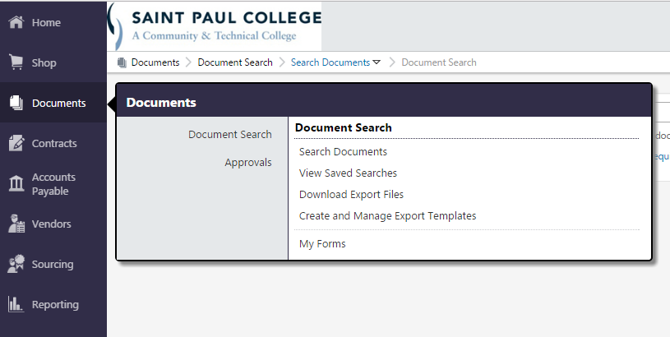

Select Purchase Orders from the drop down box in the first field and enter the PO # -- then click the blue Go button.

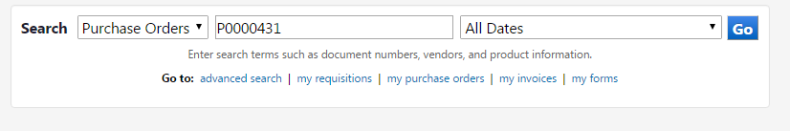

A list should appear.

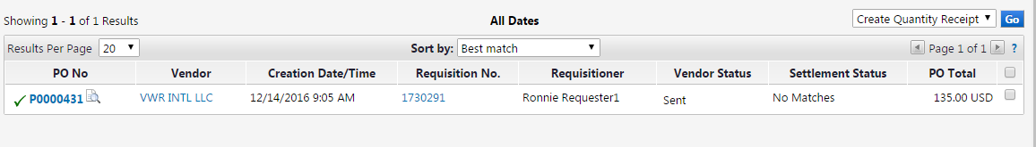

Method Two
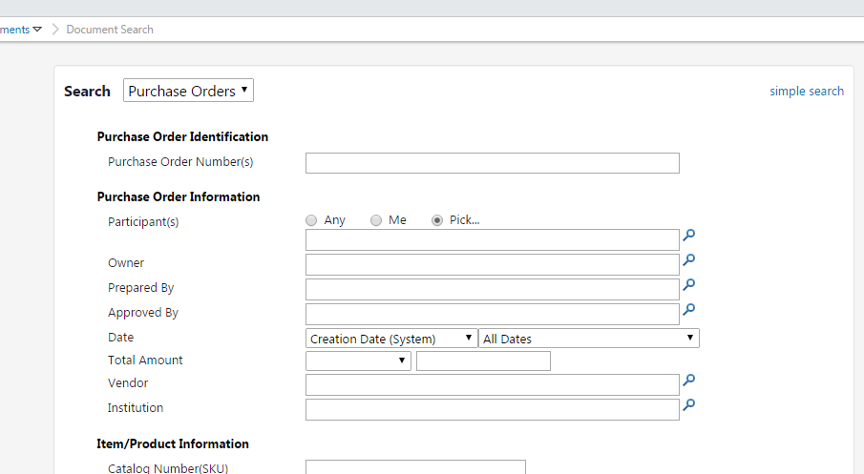
If the PO # isn’t known, clicking Advanced Search will allow you to search by many different options (Who placed the order, who approved the order, the date range, vendor name, catalog number, commodity code, etc.). You can access Advanced Search from either the Home Page or the menu item Documents > Search Documents (see the Blue Sidebar). You will need to scroll to view all the possible options.

Clicking simple search will display the simple search box as shown below.

Method Three
Go to your dashboard.
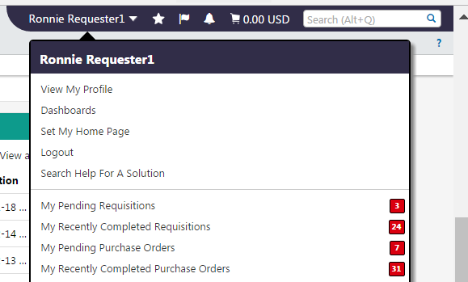

All the orders you initiated in the Marketplace will display in the My Purchase Orders widget or your saved search. In our example, Ronnie knows that he received the items from VWR and can click on the blue Number link to begin the receiving process.

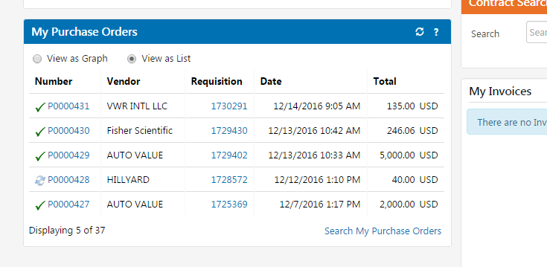

Quantity Receipts
Quantity Receipts are generally used to receive catalog or non-catalog orders for goods received.

Once the purchase order is located, click the blue PO No link > then select Create Quantity Receipt in the drop down box > then Go
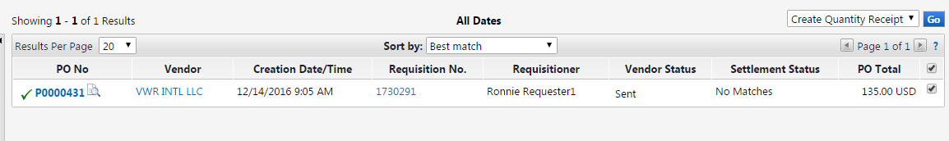

In the next screen you will enter
- A Receipt Date. The system will automatically populate today’s date. If this isn’t the actual date the product was received, overwrite the system-generated date with the actual date the product was received. Financial reporting staff refer to this as the occurrence date and it is critical to provide the date goods were received to properly reflect expenses in the financial statements.
- Packing Slip No. If the vendor sent an invoice with the shipment instead of a packing slip, use the invoice number as the packing slip number. Please send the hard copy of the invoice to the Business Office (Box #5) Packing slips may be retained or destroyed by the requesting department after being uploaded to Marketplace.
- Attach/Link the scanned packing slip (see instructions below). Attach each receipt at the header level, not the line level.
- In Notes section, enter the PO #, date goods were received and whether shipment is partial or complete if not indicated on uploaded receipt documentation along with notes regarding discrepancies, backorders, or other relevant information.
- Quantity received on each line item in Quantity. The system will default to quantity ordered. If this isn’t the quantity received, overwrite the system-generated quantity with the actual quantity received.
- Note: If this was only a partial shipment, enter the exact quantity you received. When the remainder of your order comes in you can create another receipt against the same purchase order. If entire lines were not received, you may remove the line from the receipt by checking the box to the right of the line item(s) and selecting “Remove Selected Items” from the dropdown menu above the item list. The line(s) will remain open on the purchase order for future shipments. If entire lines were returned or cancelled, you may change the Line Status from “Received” (which is the default status) to “Returned” or “Cancelled”.

To finish, click Save Updates and then the Complete button. You will receive confirmation that a receipt has been created.
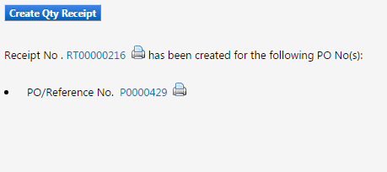

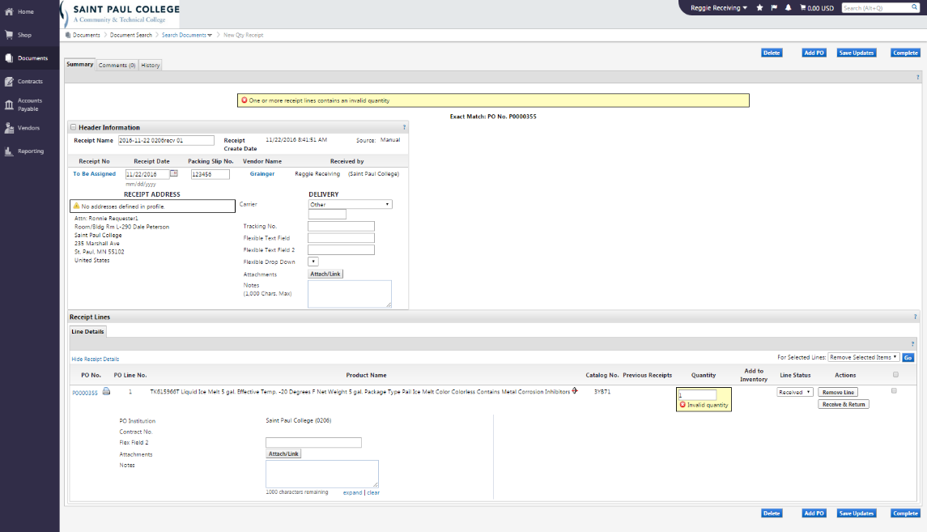

Cost Receipts
Cost receipts are generally used to receive an order for services rendered.
Once the purchase order is located, click the blue PO No link> then select Create Cost Receipt from the Available Actions menu for a Blanket Order > then GO.
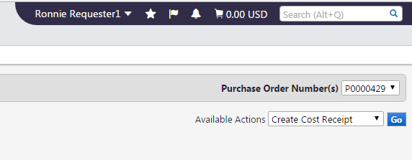
In the next screen you will enter
- A Receipt Date. The system will automatically populate today’s date. If this isn’t the actual date the product was received or the last date services were rendered, overwrite the system-generated date with the actual date the product was received or the last date services were rendered. Financial reporting staff refer to this as the “occurrence date” and it is critical to provide the date the liability was incurred to properly reflect expenses in the financial statements.
- Packing Slip No. If the vendor sent an invoice with the shipment or for the services rendered instead of a packing slip, use the invoice number as the packing slip number. Some subscriptions and memberships may not list an invoice number but may provide a member number which can be entered in this field. Packing slips may be retained or destroyed by the requesting department after being uploaded to Marketplace. Please send the hard copy of the invoice to the Business Office (Box #5)
- Attach/Link the scanned packing slip (see instructions below). Attach each receipt at the header level, not the line level.
- In Notes section, enter the PO #, date services were completed or goods were received, and whether it is a partial or final payment if not indicated on uploaded receipt documentation along with notes regarding discrepancies, backorders, or other relevant information.
- In the Cost field of Line Details, enter the exact amount of the services received. The system will automatically populate the entire amount of the purchase order which will need to be changed if it is a partial invoice or the final amount is different.
- Note: If this was only a partial shipment, enter the exact quantity you received. When the remainder of your order comes in you can create another receipt against the same purchase order. If entire lines were not received, you may remove the line from the receipt by checking the box to the right of the line item(s) and selecting “Remove Selected Items” from the dropdown menu above the item list. The line(s) will remain open on the purchase order for future shipments. If entire lines were returned or cancelled, you may change the Line Status from “Received” (which is the default status) to “Returned” or “Cancelled”.

- Click Save Updates and then Complete. You will receive confirmation that a receipt has been created.

How to Attach Scanned Receipt Documentation
Click the Attach/Link button on the Receiving screen under Header Information (not at the line level)
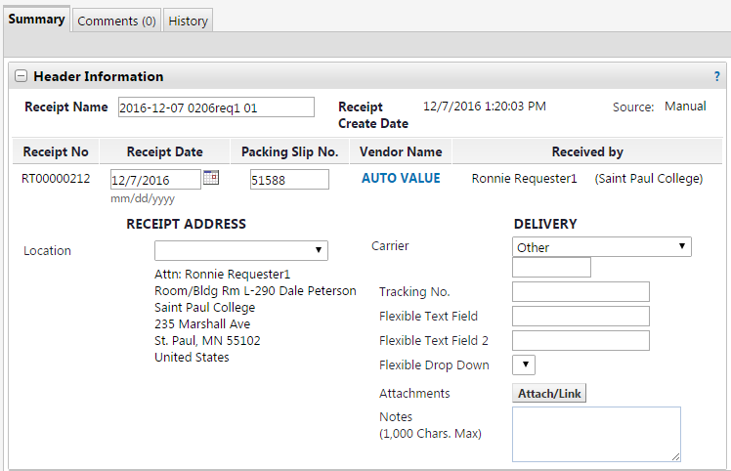

Select Choose File to find the scanned packing list file.
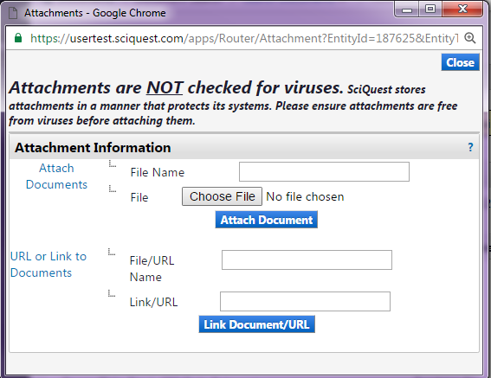

Navigate to your “Packing Slip” folder and find the packing slip. Select the file - then click Open.
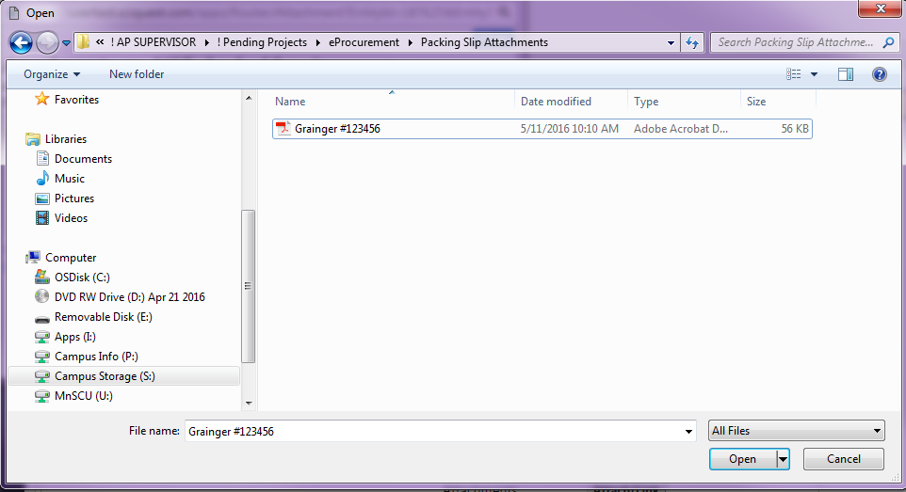

This will bring you back to the Attach/Link dialog box where you will see the sample Grainger #123456.pdf file listed. Now click on the blue button Attach Document. Select the blue Close button in the upper right hand corner if the dialog box remains open.
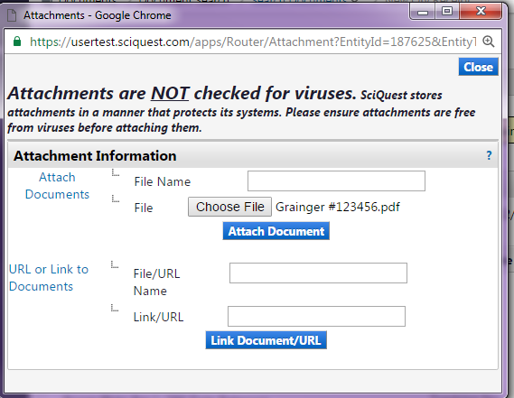

EXITING THE MARKETPLACE
To exit the software, click on your name on the bar at the upper right of the screen and from the drop down box, click Logout.
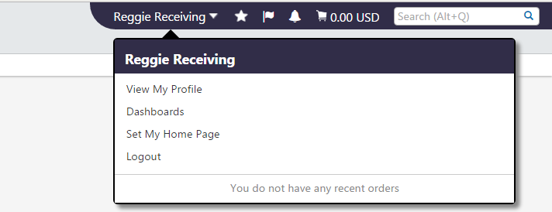

Training Revised 11/16/2020

