Tribal Identity and The Rise of the American Indian/Alaskan Native Population

Angel M. Stevens
Bemidji State University

Political Science Senior Thesis
Dr. Patrick Donnay, Advisor
May 2022
Abstract
Today, most tribal nations in the United States identify by federal recognition, yet on the American Community Survey, American Indian/Alaskan Native respondents can self-identify as a member of a specific tribal nation. Most researchers argues that this tribal identification fortifies the reflection of the American Indian/Alaskan Native identity. There are 574 federally recognized tribes in the United States today. Between 2000-2020, the US Census Bureau and the American Community Survey noted a significant surge in the American Indian/Alaskan Native population. This population growth went from a mere 2 million to almost 10 million in a 20-year time span. In this research, it is assessed who is more likely to identify as a tribal member and how this factor contributes to the population growth.

Introduction
The American Community Survey is an annual survey conducted by the US Census Bureau. Information from this survey determines where and how $675 billion in state and federal funding is dispensed today. The US Census is a demography and population tally that is dispersed every decade mandated by the federal government. The first Census was administered in 1790. Before 1860, the American Indian/Alaskan Native population were not even considered citizens.
“In 1860, census takers were instructed to enumerate only American Indians who were taxed. Taxed American Indians were those who had renounced tribal rule and exercised the rights of citizens under state or territorial laws. This primarily included American Indians who had settled in or near white communities and who had assimilated into American society. American Indians not taxed were considered to be those who lived among their kinsmen in tribal communities. The distinction between the taxed and not taxed populations was eventually dropped in the early twentieth century as the 1924 Indian Citizenship Act made all American Indians eligible for taxation.”. (Humes & Hogan, 4).
During the Indian Relocation Act of 1956, members of the American Indian/Alaskan Native population were removed and relocated from their respective tribal communities to urban areas across the United States; this author’s family members included. Finally, in 1960, the first tribal identity response was allowed by creating a self-response question on the Census. This created opportunity for tribal members that were not recognized federally and/or by their own tribe to be able to identify as the being part of the American Indian/Alaskan Native population without an enrollment number or proving blood quantum. It had a tremendous impact.
Federal recognition must be proven by lineal descent or blood quantum. Most tribes have adopted this same process to identify tribal members. Blood quantum is the process in which a fraction of the ancestor’s that identified as tribal members is used against fraction of the ancestor’s that did not identify. Someone’s Irish Grandmother would make one 5/6 if the other three grandparents identified as American Indian/Alaskan Native. Some tribes do not even recognize other tribe’s blood quantum, which lessens the member’s blood quantum as it won’t be applied towards that blood quantum. Some tribes do not recognize members that are less than a ¼. These members become known as “descendants” and do not receive the same benefits as “enrollees”, such as membership and inclusivity.
Due to questions of definition of what an American Indian/Alaskan Native is in the US Census, the Office of Management and Budget issued Directive 15:
“In 1977, OMB issued its Directive 15 policy on racial and ethnic classification for federal data. The basic racial and ethnic categories for federal statistics and program administrative reporting were defined as follows:
American Indian or Alaskan Native. A person having origins in any of the original peoples of North America, and who maintains cultural identification through tribal affiliation or community recognition.
Asian or Pacific Islander. A person having origins in any of the original peoples of the Far East, Southeast Asia, the Indian subcontinent, or the Pacific Islands. This area includes, for example, China, India, Japan, Korea, the Philippine Islands, and Samoa.
Black. A person having origins in any of the black racial groups of Africa.
Hispanic. A person of Mexican, Puerto Rican, Cuban, Central or South American or other Spanish culture or origin, regardless of race.
White. A person having origins in any of the original peoples of Europe, North Africa, or the Middle East”. (Humes & Hogan, 9).
In 1997, OMB issued revised race and ethnicity standards. The final race categories were ‘‘white,’’ ‘‘black or African American,’’ ‘‘American Indian or Alaska Native,’’ ‘‘Asian,’’ and ‘‘Native Hawaiian or Other Pacific Islander.’’ The final ethnicity categories were ‘‘Hispanic or Latino,’’ and ‘‘Not Hispanic or Latino.’’ (2009, 13).

In 2010, the US Census added the “multiracial” option to the census. This allowed respondents to identify with more than one race. Although seemingly insignificant to other races by allowing self-identification, the US Census Bureau and the American Community Survey provided ample opportunity for forgotten tribal members to receive recognition not supported by today’s society. Tribal members are more than likely to check the “American Indian/Alaskan Native” box when there are less restrictions on the definitions of the identity.

Literature Review
The identification of the American Indian/Alaskan Native must be critically defined and better accounted for. There are currently “574 Tribal entities recognized by and eligible for funding and services from the Bureau of Indian Affairs by virtue of their status as Indian Tribes”. (Federal Register, 2020). There are also over 400 tribes that are not federally recognized. In recent years, the American Indian/Alaskan Native population has grown phenomenally, reaching almost 10 million, according to the US Census Bureau. Many researchers have contributed various theories to explain the staggering increase. Meanwhile, opponents from all sides have argued that the identification of the American Indian/Alaskan Native should not be determined by the US Census Bureau because of its flawed methods. Who and what determines the American Indian/Alaskan Native identity and why is it so important to identify? In comparison of race categories, why was there such a significant surge in the American Indian/Alaskan Native population?
Investigative researchers question the numbers that have been generated over the years. They determine that although there was an increase in the American Indian/Alaskan Native population, there is also a portion of the American Indian/Alaskan Native population that remains unaccounted for. Two separate researchers, Joann Holm (2006) & Joaqlin Estus (2021) provided statistical information to show the population growth since 1990. They note the US Census divided the American Indian/Alaskan Native category into subcategories of mixed races.
“The increase between 1990 and 2000 in people identifying themselves as “American Indian alone” increased by 516,722 (or 26 percent) to a total 2,475,956 and if measuring the aggregate classification, i.e., ‘American Indian alone’ or in combination with another race the increase is 2.2 million (or 110 percent). As a comparison the total population of United States 2 grew with 13 percent, this indicates that the Native American resurgence is still underway…” (Holm, 2).
Holm shows that there was an increase in the population. The increase was to 2.2 million in the decade. She notes the population growth as a “resurgence”. Although this resurgence surprised researchers, she still believed the American Indian/Alaskan Native population is undercounted and underfunded from the federal government. After the dramatic increase in 2000 Census, no one was quite prepared for the notable increase in population in 2020. According to Estus (2021):
“American Indians and Alaska Natives living on reservations were undercounted by 4.9 percent in the 2010 census and by 0.7 percent in 2000. The 1990 Census left an estimated 12.2 percent of American Indians and Alaska Natives uncounted. The Census Bureau states that, in 2020, the American Indian and Alaska Native population (3.7 million) accounted for 1.1 percent of all people living in the United States, compared with 0.9 percent (2.9 million) in 2010. An additional 5.9 million people identified as American Indian and Alaska Native and another race group in 2020, such as White or Black or African American. Together, the American Indian and Alaska Native alone or in combination population comprised 9.7 million people (2.9 percent of the total population) in 2020, up from 5.2 million (1.7 percent) in 2010. The American Indian and Alaska Native alone population grew by 27.1 percent, and the American Indian and Alaska Native in combination population grew by 160 percent since 2010. About 4 million people identified as American Indian and Alaska Native and White, making it the largest multiracial American Indian and Alaska Native group.
The states with the largest percentages, relative to the state’s total population, of American Indian and Alaska Native alone or in combination are listed as:
Alaska (21.9 percent) Oklahoma (16 percent) New Mexico (12.4 percent)
South Dakota (11.1 percent) Montana (9.3 percent) North Dakota (7.2 percent),
Arizona (6.3 percent) Wyoming (4.8 percent) Oregon (4.4 percent) Washington (4.1 percent)
The states with the highest American Indian and Alaska Native alone are:
Alaska (15.2 percent) New Mexico (10 percent) South Dakota (8.8 percent), Oklahoma (8.4 percent) Montana (6.2 percent).”
Estus notes the increase in population but also still believes the AI/AN population is severely underfunded by the American government. He points out the increased numbers and even which states were affected by the AI/AN resurgence. Estus argues in his research that:
“…there are significantly more American Indians and Alaska Natives than were counted in the 2010 census, although advocates and early estimates say they probably were still undercounted. The changed numbers are due to population changes and to new questions and processing of answers by the Census Bureau”.
Carolyn Liebler stated in her 2016 research that the survey process itself could confuse the person taking the survey:
“Researchers designing questions to measure race and ethnicity should consider the possibility of response change, and multiple measures of race should be incorporated into data collection and analysis whenever possible” (2016, 536). Liebler divided the AI/AN category into four subgroups to determine factors that identified the American Indian/Alaskan Native: non-Hispanic, single race American Indian; non-Hispanic, multiple race American Indian; Hispanic, single-race American Indian; and Hispanic, multiple race, American Indian. Liebler and her team did extensive research on the responses of the American Indian/Alaskan Native population’s answers from the 2000 and 2010 Census answers and from the American Community Survey. They found three sets of American Indians in their study: those who had the same race and Hispanic responses in 2000 and 2010, those who moved between single race and multiple race American Indian responses and those who added or dropped the American Indian responses. She called them: stayers, joiners, and leavers. (2016, 507).
The list of each federally recognized tribe is provided by the Federal Register. Which department would oversee listing each tribe for the US Census? Would this be found under the scope of the Bureau of Indian Affairs as they determine federal recognition in the Federal Register? Perhaps the Office of Budget and Management? What is the process for the US Census in determining their self-determined survey? “The U.S. Census Bureau is an agency within the Department of Commerce. Both the Secretary of Commerce and the Director of the Census are political appointees, nominated by the President and confirmed by the Senate. The House must initiate the appropriation to conduct the census, the Senate must approve the appropriation, and the President must sign the appropriation into law. Congress requires regular reports about the census, including a report on the questions to be asked, a report that was submitted”. (Sullivan, 5). The process of detailed organization had already begun for the Federal Government. Does the US Census Bureau include reports that are from the Federal Offices that define the American Indian/Alaskan Native population? These various offices include the Secretary of the Interior, Bureau of Indian Affairs, Office of Federal Acknowledgement, Office of Budget and Management, and publishers of the Federal Register. These offices define American Indian/Alaskan Native population to determine certain benefits for the tribe, including funding. Sullivan argues that there is a check and balance between Congress and the executive branch.
Would each tribe that has enrollment records of each individual enrollee assist in providing information? Would that make it easier to pinpoint exact information? “Obtaining consent from tribal governments may involve significant time, preparation, and expense, which must be considered in planning grant applications and project deadlines. A tribe may request input into study questions, implementation, presentation of the results, and publications. Investigators who object to the review of results by non-scholars are unlikely to be allowed by tribal governments to undertake their research.” (Norton/Manson, 858). Norton and Manson noted that tribal governments did not trust outsiders with information pertaining to tribal members and were always reluctant to share information. The US Census and Tribal Government already have such long processes to begin with, would this deter success in obtaining future information? The researchers in this analysis have grudgingly determined so. The specific details that determine the American Indian/Alaskan Natives may have too much information for any one agency to list. This suggests that this may a deterrence factor with the American Indian/Alaskan Native population. Why go through such a process just to be defined as an AI/AN? Is it worth being federally recognized? Is it easier to self-identify than enroll in a tribe? The reluctance of tribal participation may contribute to the undercount of the American Indian/Alaskan Native population in the US Census and the American Community Survey.
What is the importance of being recognized as American Indian/Alaskan Native? One
researcher, Dana Hedgpeth, attempts to answer this in her study:
“American Indians are routinely undercounted in the decennial census, raising concerns among tribal leaders that they do not have enough say in how the federal government spends billions annually on housing, health care, education, roads and public safety. Officials say the undercount stems from some American Indians living in isolated communities, a long-standing distrust of the federal government and some simply not knowing the importance of the census.”. (Hedgpeth, 2).
Is it important to identify as a Native to make sure a road is built on the reservation, or a cell tower raised? Federal funding has assisted many tribes across America. This funding was created to assist the tribes in their paths to sovereignty and true self-determination. Many argue today that it created dependency on the federal government. “The census is the basis for distribution of funding for American Indian and Alaska Native schools, education, health, and housing, among other needs. Since the 2020 Census figures will be used until the 2030 census, such losses are compounded.”. (Estus, 4). Programs, such as the Education Department’s Johnson O’Malley Act, accept Certificate of Indian blood to determine its qualified applicants to receive funding for their school district. According to a report by Glenn I. Latham, he describes the startup of the Johnson O’Malley Act as: “the BIA provides funds under the Johnson-O'Malley Act of 1934 to meet the special needs of Indian students in public schools. These funds, which are largely administered through contracts with tribal organizations, public school districts and State Departments of Education, enable the contractors to provide supplemental programs for Indian students”. (Latham, 3). One cannot self-determine when applying for such program. Students need to provide tribal documentation to qualify for it. The determination of the identity of the American Indian/Alaskan Native has proven to be beneficial. Various agencies across the US must determine who is an American Indian/Alaskan Native, such as the Office of Budget and Management or the Indian Child Welfare Act. Programs such as “Title I Grants (about 90 percent of AI/AN attend Title I public schools), Head Start Programs, Native American Employment and Trainings, Indian Health Services (uses Census data for planning and program implementation), Medicaid (also provides critical supplemental revenue for the chronically under-funded IHS), Urban Indian Health Programs, Supplemental Nutrition Assistance Programs, Special Programs for the Aging (provides grants to Tribal organizations that deliver home and community-based services to Native elders), and Indian Housing Block Grant & Indian Community Development Block Grants” (Gore, 2) determine the qualifications of the AI/AN identification. Factors provided by both Estus and Hedgpeth determine that the American Indian/Alaskan Native population may have shown a tremendous increase in population, but both still believe that the AI/AN remain undercounted. They believe this relationship with the federal government deters responses from the non-responsive community of the American Indian/Alaskan Native.
The population of the American Indian/Alaskan Native has exploded over the last 20 years according to the US Census Bureau. Opposers have argued that the US Census should not be considered to determine the population numbers of the American Indian/Alaskan Native population. The identity of the American Indian/Alaskan Native is unique. There are many factors to consider when assessing the identification process. The US Census is not specific in its details and ironically, the self-determination factor should not be considered as some may not be federally recognized by government, which determines benefits. Garroute (2001) notes that that there are legal definitions for the American Indian/Alaskan Native. One cannot just decide that they are going to apply for AI/AN programs because they completed a survey stating they were part of the American Indian/Alaskan Native population.
“In conclusion, the example of Indian identity illustrates the complex and often mystifying nature of racial formation processes as they apply to American Indians. "Indianness" emerges out of complex negotiations that occur within the context of specifiable legal definitions of identity. There are many ways to gain and to lose it that may have little to do with the qualities that most people assume to be of central importance in determining racial identity. At the same time, achieving an Indian identity that satisfies various legal criteria (or failing to do so) has serious consequences. The specific elements of the racial formation process for Indian people make Native Americans' experience unique among those of modern-day U.S. racial groups”. (Garroute, 234).
In her 2020 study, Teresa Sullivan argues that “censuses are not the only way to provide statistics about the population. Population registers have been used successfully in many parts of the world. The United States has administrative records that were designed for specific purposes, but that nevertheless have potential to serve as partial population registers. A number of federal agencies have such databases, and the states have their own partial registers.” (Sullivan, 91). In her argument, the US Census should only be part of the processes that provides information about the American Indian/Alaskan Native category. Information collected should be analyzed and critiqued by agencies that are already equipped to do so. Nonetheless, that doesn’t determine whether these federal agencies have collected their information in a detailed and orderly fashion either. Their information obtained through history could be argued inefficient as well.
The identification of the American Indian/Alaskan Native has proved to be difficult and complex in its entirety. Liebler affirms this belief in her study,
“What it means to be American Indian is complicated by the existence of tribal governments, indigenous homelands, tribal enrollment blood quantum requirements, and political relationships with the federal government. A person deciding whether to mark American Indian as his or her race has extra dimensions to consider: ‘American Indian’ includes sometimes knotty political and/or legal statues (and related contested identities) that are not at issue in nonindigenous groups.”.
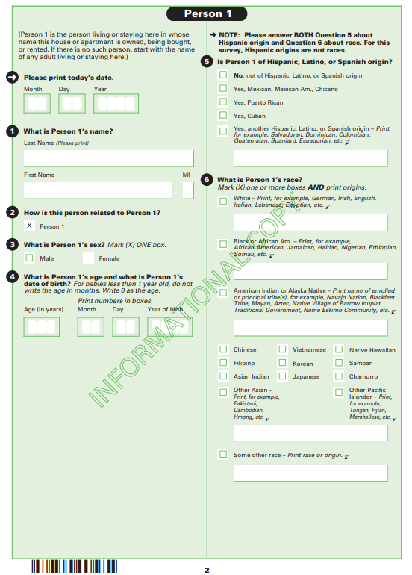
Shakespeare’s “to thy own self be true” could be not a better adage for this concept. Is being federal recognized important to the American Indian/Alaskan Native population? No. Is it socially accepted as being part of the American Indian/Alaskan Native population the trend these days? Yes. Although there is a conflicting history with the American government with the definition of being “American Indian/Alaskan Native”, there is a sense of pride and belonging that surrounds the American Indian/Alaskan Native community. Research and studies show the strong attachment of belong to this population by observing the stayers, joiners, and leavers. The empty box supplied underneath a checkbox may also indicate another type of freedom.
When analyzing the American Community Survey, it asks an American Indian/Alaskan Native to “print enrolled or principle tribe”. This could be an open-ended question for some as there are 400 tribes that are not federally recognized. If they’re not federally recognized, do they still consider themselves tribal members? In the examples listed, they use “Navajo Nation, Blackfeet Tribe, Mayan, Aztec, Native Village of Barrow Inupiat Traditional Government, Nome Eskimo Community, etc.”. Most of them are federally recognized. States have even begun the processes to recognize tribal members within the state, although some of these tribes may lack federal recognition. Mayans are considered Latin American Indian tribes. Latin American tribes are located from Mexico to Central America to South America. Does this affect their answer in a survey in the US? How many people out there identify as American Indian/Alaskan Native and specify a certain tribe? How many don’t specify? Is knowing the tribe’s history or being educated a factor when considering a specific tribe? Where are all these American Indian/Alaskan Native populations at? Are they still living on reservations? Estus (2021) did claim that Alaska had the highest American Indian population. Amazingly, Alaska only has one reservation in the whole state but hundreds of villages throughout.
2.9 million of the US population was American Indian/Alaskan Native in 2020. In this research, the 2018 American Community Survey was used. There are multiple variables when identifying an American Indian/Alaskan Native. Are there responses that were created on these surveys that contribute to the escalated surge in population? If so, which responses were they? In this study, the researcher hopes to determine the factors that contributed to the elevated rise in her unit of analysis.

Methods and Analysis
The dataset utilized in this research is from the 2019 American Community Survey. The American Community Survey is conducted by the United States Census Bureau. This survey is one of only a few surveys for which all recipients are required by law to respond and is noted on the first page of the survey. The information obtained was for 2019 and was used to determine the distribution of more than $675 million in state and federal funding. Questions are related and categorized as Social, Housing, Economic, and Demographic subjects. There are two ways to respond: via postal mail or online at http://respond.census.gov/acs.
The unit of analysis is the American Indian/Alaskan Native population. Who identifies as American Indian/Alaskan Native? There is an open box to identify specific tribes. In 1959, Hawaii and Alaska both become states. Could this have been a factor in tribal identity? One year later, the decentennial census included Alaskan Native and Pacific Islander for the first time. Both categories with ties to the American Indian community. Is inclusion a factor when deciding identification? In 1960, the U.S. Census allowed respondents to self-identify their race instead of the enumerator reporting. This change resulted in a 52% increase in the American Indian category. Were there other factors that contributed to this increase? The survey contains 2,744,205 participants (N). This analysis focuses exclusively on the American Indian/Alaskan Native population and their responses.
In comparison of the American Indian/Alaskan Native population:
- Those who self-identify as American Indian/Alaskan Native will be more than likely specify a certain tribe.
- Those who provide a specific tribal nation will be more than likely be in Alaska, New Mexico, South Dakota, Oklahoma, and Montana (Alaskan Region, Southwestern & Western Region, Great Plains Region, Southern Plains Region, and Rocky Mountain Region.).
- Those who provide a specific tribal nation will be more than likely be living in rural areas or in designated Indian locations (reservations).
- Those who specify a certain tribe are less likely to identify as having Hispanic origins, specifically Mexican origins.
- Those with higher education are more likely to provide a tribal identification.
In order to test these hypotheses, “Tribe” was utilized as the independent variable. It was also recoded into “Tribal_ID”. The “Tribe” variable is the result of the blank space provided under the American Indian/Alaskan Native checkbox to print the name of the enrolled or principal tribe. “Tribe” contained values of various tribal affiliations; some specified, some not, and some combined. After it was recoded, the values were changed to; 0. Did not specify tribal ID; 1. specified tribal ID; and 2. Combined tribal ID.
“BPL” is the general version of the birthplace of the American Indian/Alaskan Native participant. “BPL” was recoded to “Tribal_region”. “BPL” included all 50 states. The recoding process was influenced by a region map used by the Bureau of Indian Affairs (B.I.A.). This map divided American Indian/Alaskan Native tribes by 10 regions in the United States: Northwest Region, Rocky Mountain Region, Great Plains Region, Midwest Region, Eastern Region, Pacific Region, Western & Southwest Region, Southern Plains region, Alaskan region, and Hawaiian Region. The Northwest region includes Idaho, Washington, and Oregon. The Rocky Mountain region contains Montana and Wyoming. The Great Plains region includes North & South Dakota and Nebraska. The Midwest region involves Minnesota, Iowa, Wisconsin and Michigan. The Eastern region contains 28 states, which are: Alabama, Arkansas, Connecticut, Delaware, District of Columbia, Florida, Georgia, Illinois, Indiana, Kentucky, Louisiana, Maine, Maryland, Massachusetts, Mississippi, Missouri, New Hampshire, New Jersey, New York, North Carolina, Ohio, Pennsylvania, Rhode Island, South Carolina, Vermont, Virginia, and West Virginia. The Pacific Region is California. The Western & Southwest Region were combined to include the 4 Corners, the only spot in the US where 4 states meet. This region combines Arizona, Colorado, Nevada, New Mexico, and Utah. The Southern Plains region encompasses Kansas, Oklahoma, and Texas. The last two U.S. regions are self-explanatory.
“Hispan” was used as a dependent variable to determine the number of participants that claimed Hispanic origins. Values include not Hispanic, Mexican, Puerto Rican, Cuban, Other, and Not Reported.
Picture below is the Bureau of Indian Affair’s “Indian Lands of Federally Recognized Tribes of the United States. States in every region were divided accordingly.
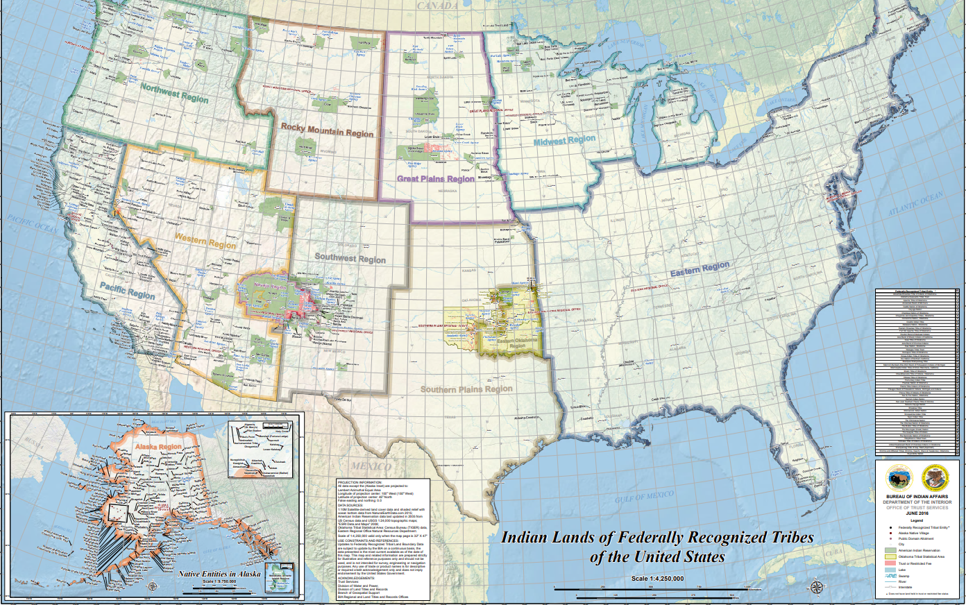

HYPOTHESIS 1: Those who self-identify as American Indian/Alaskan Native will be more than likely specify a certain tribe.
In this comparison, Tribe was recoded to the variable, Tribal_ID, and revalued from each tribe being specified to three different values that would assist in determining the outcome of this hypothesis. 139 tribes were specified in the survey. “American Indian not specified”, “American Indian not elsewhere classified”, “All Other Specified American Indian Tribe combined”, “American Indian Alaskan Native not else classified” and American Indian Alaskan Native, not specified” were the other values in the “Tribe” variable.
A frequency distribution table was obtained for the new variable, “Tribal_ID”. It concluded that 75.9% of respondents specified a certain tribe to which they belonged and/or they combined their tribal affiliations. 2,082,545 respondents claimed a tribal affiliation. 661,660 did not claim a tribal affiliation. It is assumed these respondents left this box blank.
It is concluded that Hypothesis 1 is valid: those who self-identify as American Indian/Alaskan Native will be more than likely specify a certain tribe.
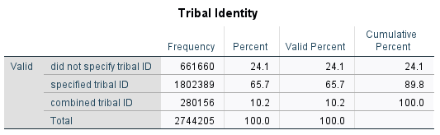

HYPOTHESIS #2: Those who provide a specific tribal nation will be more than likely be located in Alaska, New Mexico, South Dakota, Oklahoma, and Montana (Alaskan Region, Southwestern & Western Region, Great Plains Region, Southern Plains Region, and Rocky Mountain Region.). In this analysis, the new variable, “Tribal_region” was cross tabulated with “sex” and layered by “Tribal_ID”. This variable contained the 50 states within the B.I.A. region map. The U.S. states were transformed into the BIA regions.
Chi-square: 313.643 P<.001.Phi: & Cramer’s V: .053 DID NOT SPECIFY TRIBAL ID
Chi-square: 278.135 P<.001. Phi: & Cramer’s V: .033 DID SPECIFY TRIBAL ID
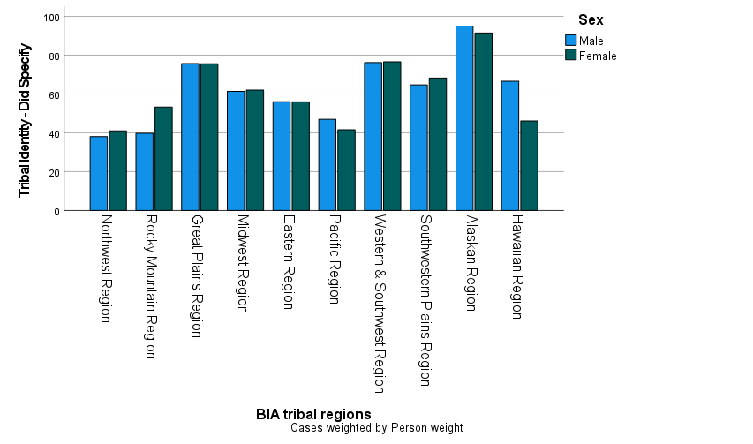
Chi-square: 516.962 P<.001 Phi: & Cramer’s V: .019 COMBINED TRIBAL ID
As shown in the graph above, the top three areas were the Eastern Region, Western & Southwestern Region, and the Southwestern Plains Region. Those that self-identify will more than likely live in these regions with gender not being a significant factor in determining region but self-identification being significant. This hypothesis was developed after consideration of the Indian Relocation Act of 1956, which may be a factor that contributes to tribal identification.

HYPOTHESIS 3: Those who provide a specific tribal nation will be more than likely be living in rural areas or in designated Indian locations (reservations). “Migtype1” was transformed into “urban_or_rez” to test this hypothesis. This variable was transformed into “rural/rez, mixed, or urban”. The legacy dialog box was used to graph a clustered bar chart. “Other Statistic” was checked under the Bars Represent box and “Tribal_ID” was placed in the open box. “Change statistic” was then clicked to use the Percentage Inside option. (1) was used because it represented “Did Specify”. “Tribal_region” was used for Category Axis and Define Clusters was filled in by “Urban or Rez”.
Chi Square = 19610.655 .000, Phi = .536, Cramer’s V = .379 Rural/Rez
Chi Square = 25416.950 .000, Phi = .284, Cramer’s V = .201 Mixed
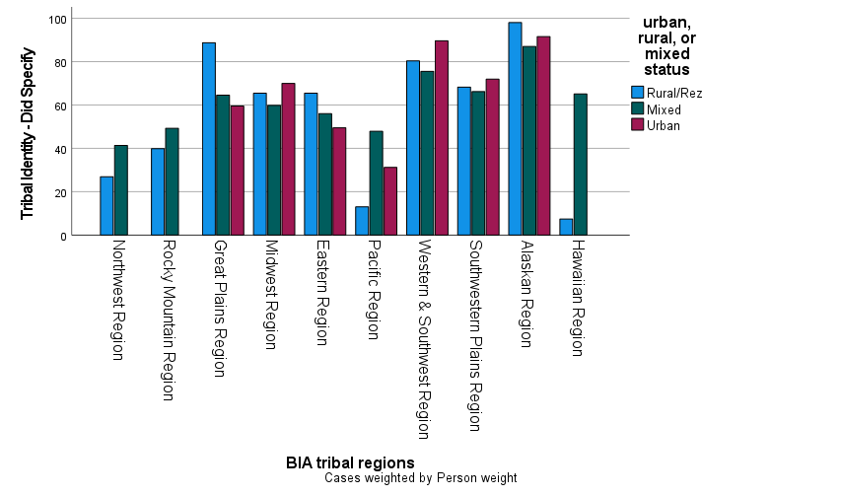
Chi Square = 4365.009 .000, Phi = .400, Cramer’s V = .282 Urban

The Alaskan region, Southwestern Plains, Western & Southwest Region and Midwest region had the highest population of Urban AI/AN. The Alaskan Region, the Great Plains Region, Western & Southwestern Region, and Southwestern Plains Region had high population of rural/rez population. This hypothesis was created because researchers had argued that rural/rez population of AI/AN were harder to access than the urban AI/AN. Out of those that specified a tribe: 68,218 respondents claimed rural locations; 27,348 claimed urban location; while 314,470 had mixed responses, indicating that they moved back and forth. This combination response diminishes the hypothesis as answers vary by region.
HYPOTHESIS #4: Those who specify a certain tribe are less likely to identify as having Hispanic origins, specifically Mexican origins.
Chi Square = 36745.784 .000, Phi = .340, Cramer’s V = .240 NON-HISPANIC
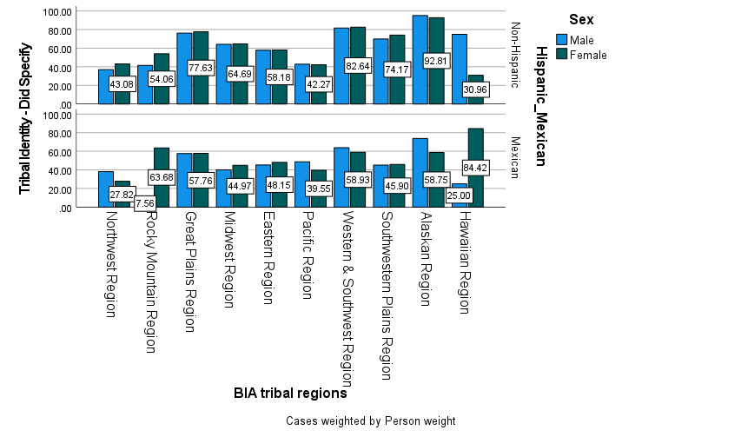
Chi Square = 5238.600 .000, Phi = .283, Cramer’s V = .200 HISPANIC-MEXICAN
In 2010, instructions stating: “for this census, Hispanic origins are not races” was added to the survey. It was added before the race category within the survey. “Hispan” was used as the independent variable with “Tribal_region” cross tabulated with the control variable, “Tribal_ID”. This allowed the researcher to divide the three categories of the American Indian/Alaskan Native by region and the number of participants that checked the “Hispanic” box on the survey. Most of the combined tribal identification participants did not claim Hispanic origins. The ones that did, majority had Mexican heritage and resided within the B.I.A. region map. Surprising, there was a large population that self-identified as American Indian, Hispanic, specifically Mexican, male that lived in the Hawaii region. There is also a large population of self-identifying American Indian/Alaskan Native, non-Hispanic, female population in Hawaii as well.
HYPOTHESIS #5: Those with higher education are more likely to provide a tribal identification.

Chi Square = 852.981 <.001, Phi = .025, Cramer’s V = .018 MALE
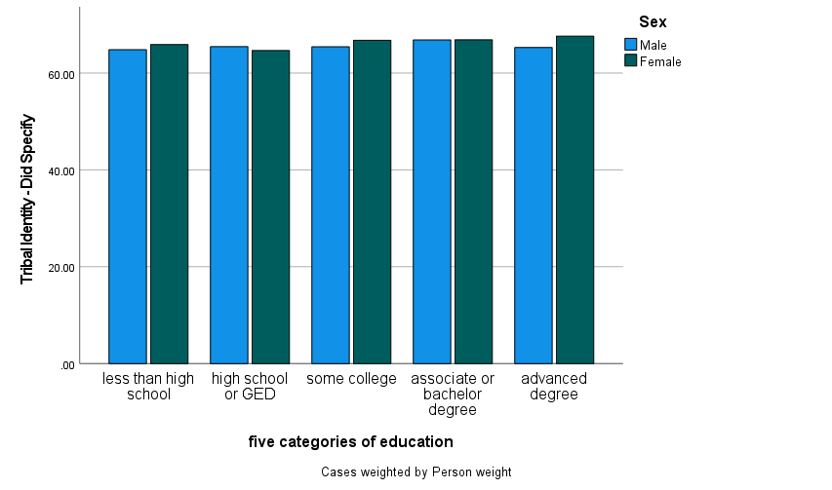
Chi Square =1990.387 .000, Phi = .038, Cramer’s V = .027 FEMALE

“Educ” variables were divided into 5 categories of attainment: less than high school, high school or GED, some college, associate or bachelor’s degree and advanced degree. The “Educ” was cross tabulated with “Tribal_ID” and layered by “sex”. This hypothesis was created it seemed there were benefits to being American Indian/Alaskan Native; education being one of those benefits. Education also a leading factor in learning about those specific benefits. Education has only a slight impact. Sex is also significant but also not a determining factor in deciding education for an American Indian/Alaskan Native scholar.
Benefits obtained by the American Indian/Alaskan Native population can be received by anyone else except that of Indian Health Services and programs utilized by the tribes on their respective lands. These tribal programs can be developed off reservation as well by non-Natives as non-native programs.
From 2,744,205 participants (N), the American Community Survey had provided information about the American Indian/Alaskan Native population. This research focused on the American Indian/Alaskan Native population. With this information, the following has been tested:
In comparison of the American Indian/Alaskan Native population:
- At least two thirds of the population claim a specific tribe.
- Those who provide a specific tribal nation will be more than likely be located in Alaska, New Mexico, South Dakota, Oklahoma, and Montana (Alaskan Region, Southwestern & Western Region, Great Plains Region, Southern Plains Region, and Rocky Mountain Region.).
- Those who provide a specific tribal nation varies by region.
- Those who specify a certain tribe are less likely to identify as having Hispanic origins, specifically Mexican origins.
It was determined that those who self-identify in the American Community survey, majority of those are located within the B.I.A. region map, which includes all 50 states of the U.S. Those that self-identify, over 75% provided a tribal identification. Those with combined tribal identification did identify with Hispanic origins, specifically Mexican origins. A total of 37,665/43,939 respondents did not claim Hispanic origins. The highest percentage of the respondents with Hispanic origins was the 341 respondents located in the Rocky Mountain region. This particular group also claimed specific Mexican heritage along with their combined tribal identification. It is concluded that that those who self-identify as American Indian/Alaskan Native are more than likely to claim a tribal affiliation and live within the United States going back and forth between rural/rez and urban areas. Those that do self-identify as American Indian/Alaskan Native on the American Community Survey feel the freedom to do so, despite federal recognition or tribal recognition; the two leading contenders for definition of identity.
“What is needed, as explained by Beckenhauer, is to work toward a functional definition of identity, one of how to reconcile cultural affiliation and self-identification with exclusionary definitions based on biology, a necessity to effectively allocate limited federal funds, thus striking a balance between inclusivity and exclusivity. Identity is not something that can be cordoned off with definable, fixed boundaries. It must be in continual process, one that allows a fluid identity fixed in cultural construction, not something inherently and innately fixed in the human genome, defined by blood or any other facet of biology (real or imagined).” (Schmidt, 10).
The complexity of tribal identification is identified by various variables and factors, such as region, sex, and tribe. This study shows that the American Indian/Alaskan Native population move between rural and urban areas, although preference for the rural/rez area comes in second. Education has a slight contribution to self-identification but not a significant factor. Checking “Hispanic” does not have a factor in self-determination but there is a high percentage of Mexican men living in the state with the highest AI/AN population. The American Community Survey now allows the American Indian/Alaskan Native population to express their own lineage with a multiple-choice option. A choice that hasn’t been an option for many throughout their history. A choice that has been determined for them throughout many governmental processes. This seemingly simple gesture from the US Census and the American Community Survey symbolizes the complex history of the AI/AN and their sense of identity.

Bibliography
American Community Survey. (2022). https://www.census.gov/programs-surveys/acs

Elder, Allison Krause. (2018) Indian” as a Political Classification: Reading the Tribe Back into the Indian Child Welfare Act. Northwestern Pritzker School of Law Scholarly Commons. (416-438).

Estus, Joaqlin. (2021). Indian Country Today. “US Census Says American Indian Undercounted by Tens of Thousands”. Billings Gazette, Billings, Montana. https://www.proquest.com/newspapers/us-census-says-american-indian-undercounted-tens/docview/2594880017/se-2?accountid=26406

Federal Register. (2019). “Indian Entities Recognized by and Eligible To Receive Services From the United States Bureau of Indian Affairs”. Bureau of Indian Affairs. 86 FR 7554. PP: 7554-7558. https://www.federalregister.gov/documents/2021/01/29/2021-01606/indian-entities-recognized-by-and-eligible-to-receive-services-from-the-united-states-bureau-of
Garroutte, Eva Marie. (2001). The Racial Formation of American Indian: Negotiating Legitimate Identities within Tribal and Federal Law. American Indian Quarterly, pp. 224-239. http://www.jstor.org/stable/1185951

Gore, Carol. (2018). Senate Indian Affairs Committee Hearing. Washington: Federal Information & News Dispatch, LLC. https://www.proquest.com/other-sources/senate-indian-affairs-committee-hearing/docview/2002179175/se-2?accountid=26406

Hedgpeth, D. (2019). Census, Tribal Leaders Push for American Indian Participation in 2020 Census: The Population Group Has Routinely Been Undercounted by Nearly 5%. The Washington Post, Washington, D.C. The Washington Post: Breaking News, World, US, DC News and Analysis https://www.washingtonpost.com/local/census-tribal-leaders-push-for-american-indian-participation-in-2020-census/2019/06/13/dc9860f2-7be9-11e9-8bb7-0fc796cf2ec0_story.html

Holm, Joann. (2006). “The Resurgence of Native American Identity. A Case Study of the Wampanoag Tribe of Gay Head (Aquinnah)”. Department of Political Science, Lund University. http://lup.lub.lu.se/student-papers/record/1325607

Humes, Kathy and Hogan, Howard. (2009). Measurement of Race and Ethnicity in a Changing, Multicultural America. Online Publication. Springer Science+Business Media, LLC. PP: 21 DOI 10.1007/s12552-009-9011-5

Iron Cloud, Laurel. (02/2019). “Indian Entities Recognized by and Eligible to Receive Services from the United States Bureau of Indian Affairs”. Federal Register. Indian Affairs Bureau. 84 FR 1200. Pages 1200-1205. Federal Register :: Indian Entities Recognized by and Eligible To Receive Services From the United States Bureau of Indian Affairs .

Latham, Glenn I. (1985). “The Educational Status of Federally Recognized Indian Students Enrolled in or Eligible for Enrollment in BIA and BIA Contract Schools, and Schools Receiving Support VIA the Johnson-O'Malley Act.”. Paper presented at the Evaluation Network/Evaluation Research Society (San Francisco, CA, October 10-13, 1984). PP: 20.

Liebler, Carolyn A. (2018). Counting America’s First People. The ANNALS of the American Academy of Political and Social Science. (180-190). doi:10.1177/0002716218766276

Liebler, Carolyn A., Bhaskar, Renuka, and Porter, Sonya R. (2016). Joining, Leaving, and Staying in the American Indian/Alaska Native Race Category Between 2000 and 2010. Population Association of America, 507-540.

Nagel, Joane. (1995). American Indian Ethnic Renewal Political and the Resurgence of Identity. American Sociological Review, pp. 947-965.

Norton, Elena M. and Manson, Spero M. (1995). “Research in American Indian and Alaska Native Communities: Navigating the Cultural Universe of Values and Process.”. Journal Of Consulting and Clinical Psychology. (856-860).

Schmidt, Ryan. (2011). American Indian Identity and Blood Quantum in the 21st Century: A Critical Review. Review Article. Journal of Anthropology. Vol. 2011, Article ID 549521, PP: 9. doi:10.1155/2011/549521

Shumway, J. M., & Jackson, R. H. (1995). Native American Population Patterns. Geographical Review. (pp. 185–201).

Sullivan, Teresa A. (2020). Census 2020: Understanding the Issue. Switzerland, A.G., Springer Nature. (113 pages).

Thorton, Arland and Linda Young-Demarco. (March13th, 2021). Federal Decennial Census Data for Studying American Indians. Working Paper. Institute for Social Research; University of Michigan. (40 pages).

U.S. Census Bureau. (2022). https://www.census.gov/en.html

Vespa, Johnathan; Medina, Lauren; & Armstrong, David M. (rev.2020). Demographic Turning Points for the United States: Population Projections from 2020 to 2060. US Census: Current Population Reports. (15).

