Has There Been Another
“Ferguson Effect”?

Megan Majewski

Senior Thesis Political Science
Bemidji State University
Dr. Patrick Donnay Advisor
May 2022

Abstract

On May 25th, 2020, America stood still as they watched the video of Officer Derek Chauvin press his knee onto the neck of George Floyd leading to his death. Protests, riots, and calls to defund the police all ensued in the following months. I focus on how Floyd’s death changed attitudes towards law enforcement and may have contributed to an increase in crime, similar to the idea of a Ferguson effect, perhaps there was a Floyd effect in 2021. I focused this research on 69 cities, using crime data from the Major Cities Chiefs Association. I then measured public concern, by using Google Trends to find the ratio in Black Lives Matter searches and Blue Lives Matter searches. Initial analysis shows that there is a slight Floyd effect seen when taking the Google Trends data as the independent variable and running that with the dependent variable of the percent change in homicides from 2020-2021. Data shows as the ratio from the searches increases, the percentage of homicides also increases. This can also be seen slightly when looking at both robberies and aggravated assaults.

Introduction
May 25th, 2020, in the early mornings American’s froze as they watched a grave video of an unarmed black man being pinned to the ground by the force of a police officer. The officer’s knee was compressing the man’s neck leading to his death. This man was George Floyd. Stories similar to this one are becoming a phenomenon that is leading to a division of our nation. We live in a time where some now call for the police to be defunded because of the growing distrust in their work. Due to this division, we have seen times where police were the specific target of crime. For example, in 2016 Dallas, Texas a man angered by shootings of black men took matters into his own hands and ended up going on a shooting rampage targeting police. He killed five officers and wounded nine others. It is almost unfathomable that tensions against police could reach such a heightened point. The research shows a clear connection between different variables, such as type of contacts or interaction with police, that lead to several variations in people’s overall perception of police, how race and neighborhood affect attitudes towards police, and how all of that can lead to a phenomenon called the Ferguson effect. In short, the Ferguson effect is a change in public mood or an increased concern about law enforcement from the public, that leads to police being more timid or even changing policy in ways that lead to an overall increase in crime rates.
Noticeably crime was becoming an issue in more places than the usual subjects as it was now affecting most of the country. “Pollster Mark Penn, co-leader of the Harvard/Harris survey, now says rising violence is the single most important issue for the 2022 midterms” (Lipson 2021). It’s important to know why crime is rising if it is becoming such a crisis in America. Research has proven there is a connection between negative perception/concern in law enforcement leading to a rise in crime, specifically violent crimes such as homicide, rape, robberies, etc. My research is going to mimic the Gross and Mann piece but focus on the time period post George Floyd to see if there was Floyd effect.
Perception of Police
Considerable research speaks specifically about the perception of police, how separate groups of citizens view police, the work they do, whether their work is legitimate, the force they use, and what effects the perception of police. In a National Institute of Justice study, it was found that the more informal police contacts citizens have the better was their perception of police compared to citizens that have had formal contacts with police. (Maxson, Hennigan & Sloane 2003). Formal contacts with police could mean arrests, getting pulled over, and other things of that nature. Informal contacts could be an officer teaching a D.A.R.E. program to a high school class, or rewarding a young child for riding a bike with a helmet on by giving him an ice cream coupon. Davis and Hendricks (2007) distinguished between informal and formal contacts. As well as voluntary and involuntary contact. They also compared immigrants to native born citizens. “Immigrants rated the police more positively than native-born Americans on measures of police effectiveness, police misconduct, and satisfaction with both voluntary and involuntary contacts” (Davis & Hendricks, 2007, p. 91). Although immigrants in that research reported a higher perception of police, the study also finds they were ultimately less likely to call the police for help compared to native born Americans. This points to how the public view police and how there are variations in this between groups. As stated previously, perception of police or concern is a key piece to the idea of a Ferguson effect. Change in public view or concern between one group or all groups will in theory affect crime.
Research by Hinds (2009, p. 54) found similar results when it came to specific kinds of police contact. “Satisfaction from citizen-initiated contact with police was found to explain the largest amount of public satisfaction with police”. Hinds also found three factors that were even more influential in shaping public satisfaction than citizen-initiated contact. Those three factors were people’s views of police performance, police legitimacy, and police use of procedural justice. In simpler terms police legitimacy can be explained as the willingness of the public to obey or cooperate with police. Procedural justice is the idea of fairness of the process that resolves disputes and the use of resources. These concepts are in related work that to measure perception and other ideas relating to police.
A key group to look at is a group that has had formal contacts with police are arrestees. The arrestees in this study by White, Mulvey and Dario were from Maricopa County, Arizona between the years 2010-2012. The researchers found that perceptions of police legitimacy did not vary by offender type. They also found that “perceptions of fair and just treatment led to acceptance of the police as a legitimate source of authority which, in turn, generates greater willingness to cooperate with police” (White, Mulvey & Dario, 2016, p. 357). This is critical because it allows us to understand that when actions are fair, or seen as such, even if someone is getting punished, they are accepting of their punishment.
Society, specifically Americans, have seen videos of acts by police that some would say are in fact inhumane, unfair and unjust which is where the tension against police gains credibility. However, some find that some community groups are willing to work alongside police to better their communities. A piece by Urban Institute (2017) finds just that idea to be true. “Residents’ have a strong belief in the law and a high willingness to partner with the police. These findings suggest that the ground may be more fertile than expected for repairing relationships between community members and the police” (Vigne, Fontaine & Dwivedi, 2017, p.15). What is interesting about this, however, is that this study focused on people in low-income areas with high crime and unfortunately, they report back a negative view of police across measures of procedural justice, police department legitimacy, police bias, and community policing. It is rather unfortunate that this specific group of people feel that way because they reside in high crime areas that need more and better policing in order to try to help the situation. That is why the ground is fertile to reconstruct these relationships because people of the community know fixing those relationships will hopefully help fix their community as well.
Something to note about communities regarding perception of police is that “groups to which we belong can influence the way we see the world. If we believe that other people around us believe the police are legitimate, then we are more likely to believe the police are legitimate” (Antrobus, Bradford, Murphy & Sargeant, 2015, p. 165). The climate is changing now because more and more people don’t see the police as legitimate. We see this now when groups like Black Lives Matter grow and the rhetoric of Defund the Police rises. Communities have even considered putting new programs in place and abolishing the police altogether.
The perception of police is also altered by partisanship. Republicans and Democrats vary widely in how they report back on overall police performance. They also vary when it comes to the use of force and how it's applied within a situation. A Pew Research Center study done in 2017 found that “76% of white Republicans say they feel police around the country are doing an excellent or good job treating racial and ethnic groups equally, compared with 27% of white Democrats – about the same difference as between all Republicans and Democrats” (Brown 2017). A year earlier a Cato Institute survey covering policing in America as a whole also found partisan divides. “Stark racial and partisan divides in favorability toward police, but no group is anti-cop” (Ekins, 2016, p.1). The reason that this survey concluded that no group is anti-cop was due to the fact that even though groups would express negative views of police there was too weak of an assertion to also call their feelings or view anti-cop.
Neighborhood & Race
A key piece to the problem of police perception we are now facing and where it gained momentum, is when negative contacts between police and unarmed black men or women have occurred. We have seen this with Michael Brown in Ferguson, Freddie Gray in Baltimore, Brianna Taylor, and George Floyd to name a few. There is no way to ignore race as a factor here, research has proved this repeatedly.
Research on this topic specifically brings up the idea of racially based policing. The idea that police suspect certain races and or ethnicities of committing crimes based on those predetermined factors. “Being male, having prior experiences with police discrimination, having parents who were discriminated against by police, experiencing school suspension or prior arrest, adopting of street code values, and living in an urban neighborhood were all significant predictors of [reports of] racially biased policing” (Wihbey 2012). The neighborhood and type of the community strongly affects the perception of police. To continue, “Significantly higher levels of perceived police-based racial discrimination in predominantly white neighborhoods that experience black population growth and in neighborhoods with higher levels of affluence” (Wihbey 2012). This finding makes it clear that it’s not just poor communities that may see some levels of racially based policing. Stewart, Baumer, Brunson & Simons, (2009) found that “black adolescents most frequently are discriminated against by the police in predominantly white neighborhoods” (p. 870). So even in white neighborhoods blacks may experience this racially based policing.
Everyone’s environment is crucial to their socialization and upbringing. The environment leads to specific views, beliefs, and nature in which people act. Research I found specifically pulled data from a group of students in Chicago, Illinois. Researchers found that “African American youth are more vulnerable to police contacts than are Latinos, who are more at risk than whites” (Hagan, Shedd & Payne, 2005, p. 381). This is a piece of information that is easily assumed, especially within today’s climate. However, they also found that “Latino youth respond more strongly and negatively to police contacts even though experience fewer of them” than other groups specifically African Americans (Hagan, Shedd & Payne, 2005, p. 381). That piece pulls focus off the typical black vs. white scope that we normally see. There is, however, a black vs. white gap in treatment which is seen not just pertaining to police. A Pew Research Center study in 2013 looks at the treatment of citizens by police, court systems, and other community institutions. The study found that blacks are more likely than whites to say that they as a group deal with more mistreatment. Also, “adults who live in urban areas, regardless of their race, are much more likely than those living in rural areas to see racial inequality” (Patten 2013). This makes sense as we see more crime in large cities. We also see more protests break out in these larger cities even if the crisis didn’t happen there, for example George Floyd occurred in St. Paul and there were protests in many cities across the world.
Ferguson Effect
There is less research on the Ferguson effect specifically because it is a more recent idea. The hypothesis of the Ferguson effect is best explained by Neil Gross and Marcus Mann “As the Black Lives Matter movement gained support following protests in Ferguson, Missouri, perhaps police officers worry about the new public mood, scaled back their law enforcement efforts, with more crime as a consequence” (Gross & Mann, 2017, p.1). Essentially the argument is that due to the microscope police felt they were under they stop policing areas as much as they typically would. The idea is that there was then room for criminals to commit more crime, which, it is argued, is why we see crime rates rise post Ferguson. Gross and Mann’s focused on 43 cities. They measure public concern, or shift in public mood towards law enforcement, typically a negative shift towards distrust in police, by using a commercial interface produced by Google called Google AdWords to identify the number of searches of key phrases that would represent concern. They found that there was a connection between public concern and crime rates. “With a 10% rise in homicides, a one standard deviation increase in search activity is associated with a rise in other violent crime of about 3%” (Gross & Mann, 2017, p.10). Looking at crime statistics alone in the 43 cities, homicide had a mean increase of 16%. A piece by Mike Maciag (2016) found comparable results, “University of Missouri-St. Louis professor Richard Rosenfeld found a spike in homicides between 2014-2015. Where 56 large cities saw an average 17 percent increase in one year” (Maciag 2016).
Methods and Analysis
The data for this study comes from the same sources as the Neil Gross and Marcus Mann 2017 study which analyzed how public concern relating to crime may lead to the Ferguson effect. The data they used for crime, which I will also be using, is from an organization called the Major Cities Chiefs Police Association also known in short as the MCCA. The MCCA focuses on crime data from the largest cities in the United States and Canada. I analyze the same 43 cities that Neil Gross and Marcus Mann used in order to compare findings. However, I was able to include additional cities bringing my total to 69 cities within the United States. Some minor problems did arise when using this source of data. There was sometimes missing data from cities in one set of reports but not another. This is due to the fact that different police departments are responsible for sending their data to the MCCA. For example, Austin, Texas had no data for the full year of 2019-2020, this was also partially true for New York City, Milwaukee, and Wisconsin which had no data provided for January to June of 2019 and 2020. Sacramento, California, New Orleans, and Louisiana had no data except for the time period of January to June of 2020 and 2021. I also later excluded Oklahoma City because they were too much of an outlier, having homicide rates increases by 1900%. So, my final number of cities used was 68. Besides those minor inconveniences all the rest of the data was provided.
Attempting to replicate Neil Gross and Marcus Mann’s 2017 study was compiling Google Trends for each city under study. Gross and Mann use Google AdWords for getting a total count of internet searches as a measure of public concern. Google AdWords is costly and due to that I used Google Trends. Instead of focusing on the same key phrases, such as cop shooting, I hate police, police brutality, and so forth I focused on two key terms/phrases. Those key phrases were Black Lives Matter and Blue Lives Matter. I gathered Google Trends data on the same 69 cities on which I had crime data. One problem here is that some of those cities were summarized as counties in a Google Trends. Also, there were times where it would combine together two cities giving them the Google Trend data. For example, this happened with cities in California (Long Beach, Los Angles, Oakland, San Francisco, and San Jose).
The first time period I pulled data from was June to December of 2020 and the second time period I pulled from was January to June of 2021. I took the average value of searches for both Black Lives Matter and Blue Lives Matter for each city and then created a ratio of the two by taking Blue Lives Matters average and dividing it by Black Lives Matter average. I did this for both time periods. I did this in order to measure public concern, thinking a large amount of Black Lives Matter searches would connect to the idea of a lack of faith in law enforcement.
Hypothesis One: With the standardization of the Blue Lives Matter over Black Lives Matter ratio I am expecting to see when the ratio is high that there is also an increase in homicides.
(Figure #1)
(Figure #2)
After running these two scatterplots what is being seen is the opposite of my theory. Initially I expected the line to be flipped in the sense that when that ratio is closer to 0, which means more Black Lives Matter searches, the homicides would be higher in that city. However, what we are seeing is as you move closer to the one-to-one ratio of Blue Lives Matter over Black Lives Matter, we see the number of homicides increase. A way to interpret this is the more people searching Blue Lives Matter the bigger increase in homicides in those cities. Due to this I reevaluated what my Google Trend data could mean. Instead of measuring public concern, or a lack of faith in law enforcement, I think a better way to interpret it is the tensions between Black Lives Matter and Blue Lives Matter, hostile and almost polar groups to one another, the more homicides increase in those cities.
Hypothesis Two: Analyzing crime data and census data together I am going to compare the levels of homicide rates compared to persons in poverty. As the level of poverty is increased in the cities, I expect the rate of homicides to increase. This is due to the idea that typically poverty is a good predictor of where we will see elevated levels of crime, in this case homicides.
(Figure #3)
(Figure #4)
Analyzing these two scatterplots we see a slight increase in robberies as the number of people in poverty increases within the cites. However, this increase is very minimal. The increase does appear to be slightly higher in the second six months post George Floyd than the first six months. These scatterplots support my hypothesis that the higher number of people in poverty an increase in robberies, however this relationship is not strong.
(Table #1)
This multiple regression analysis is used to isolate the effect of one independent variable on the dependent variable while controlling the effects of other independent variables. This allows us to weigh different effects at the same time and gather a better understanding of what is happening with the data. The different independent variables I used here were the Google Trends data, persons in poverty, educational attainment (which is listed above as bachelor’s degree or higher), and employment (which is listed above as in civilian labor force, total, percentage of population). These independent variables are run against the percent change in homicides. Interpreting this table, we do not see a lot of significance. This is due to the fact that we only had 68 cities, it is hard to obtain significance when the number of cases is that low. Starting with the Google Trend data we see that as the number of homicides increases the Google Trend data keeps shifting upwards as well,18.421, therefore the opposite of a Floyd effect, endless we interpret the trend data as more of hostility between to the groups rather than public concern. However, that number is not statistically significant so it could be due to chance and overall is not reliable, this is true for all variables except education. Next is persons in poverty and in the first six months we see a negative relationship of -.953 as the number of homicides increases, however this changes in the following six months. In the second six months we see as the percentage of homicide increases the number of people in poverty increase 1.010. Moving to education attainment, we see that as the number of homicides increases the number of bachelor’s degrees obtained decreases by -4.358, therefore stating that homicides go up as less people are educated. However, the interesting piece of data in this table is that the following six months show the opposite and that is the only significant statistic we see on this table. That significant statistic shows that as the number of homicides increases the number of educated people also increases by 1.146, this is rather counterintuitive than what is typically thought to be the relationship between crime and educational attainment. Finally looking at employment we see that as the number of homicides increases by 7.578 in the first six months post Floyd the number of employed people increases. This is also counterintuitive as well, however not significant. Also, this relationship flips when looking at the second six months post George Floyd as the homicides increase employment goes down by -1.730, more of a common idea in criminology.
Hypothesis Three: Analyzing crime data and Google Trend data together I am going to compare the level of public concern, the ratio between volume of searches of Black Lives Matter and Blue Lives Matter, to the changes of robberies. I am expecting to see an increase robbery rate for cities that have a lower ratio between Blue Lives Matter and Black Lives Matter, meaning Black Lives Matter was searched more in the areas with higher robbery rates.
(Figure #5)
(Figure #6)
These scatterplots show once again the opposite of my theory, or do not support my hypothesis. We are seeing as the ratio gets closer to a one-to-one ratio of Blue Lives Matter over Black Lives Matter the number of robberies increases. Another way to say this is the more people that search Blue Lives Matter the higher the crime. Or once again the alternative interpretation of the Google Trend data is that it captures the increase in hostility between the two groups that leads to the increase in robberies.
Hypothesis Four: Analyzing crime data and census data together I am going to compare the levels of robbery rates compared to persons in poverty. As the level of poverty increases in the cities increases, I expect the rate of robberies to increase. This is due to the idea that typically poverty is a good predictor of where we will see elevated levels of crime, in this case robberies
(Figure #7)
(Figure #8)
These Scatterplots show an odd relationship between the percent change in poverty and the persons in poverty. In the first 6 months post Floyd’s death we do not see much going on if we were to say anything maybe there is the slightest increase in robberies. However, looking at the second set of six months post Floyd we see that as the number of people in poverty increases robberies decreases. This does not support my hypothesis and is also something we are seeing that is also counterintuitive.
(Table #2)
This multiple linear regression shows the percent change in robberies against the different independent variables I used the Google Trends data, persons in poverty, educational attainment (which is listed above as bachelor’s degree or higher), and employment (which is listed above as in civilian labor force, total, percentage of population). This second table compared to the first one, which involved the percentage in homicides, has an even smaller effect, or smaller numbers regarding the change we see as robberies increase. For example, looking at Google Trend data we barely see an increase in that ratio as the percentage of robberies increase. This stays the same for both the first six months and the second six months. Continuing down the table, to persons in poverty has a .008 increase in the first six months and no change in the second six months. Next with educational attainment we see that as the number of robberies increases the number of bachelor’s degrees obtained goes down by -.002, however we see an increase of .008 in the following six months. The first and only statistically significant factor we see is employment regarding the first six months. As the number of robberies increases, we see a slight increase of .028 in employment. However, in the following six months we see this change to a negative change, although not something of statistical significance.
Conclusion
Overall, I have not proved a Floyd Effect when utilizing the Google Trend data as a measure of public concern or lack of faith in law enforcement. I think if we interpret that data as being a measure of hostility resident interested in Blue Lives Matter and Black Lives Matter, we can see a connection of heightened tensions leading to an increase in crime when looking at homicides and robberies. However due to my small sample size it is hard to acquire statistical significance with my data. Therefore, I am unable to prove anything with certainty. Another problem with the Google Trend data is that it was volume of searches instead of actual search counts. If I were to do this study again, I would try to use Google AdWords because I think it would do a better job of measuring that public concern.
In the end it is hard to explain why crime happens and what causes it to increase. I do still believe that after the death of unarmed black men hit the news it causes a reaction by both the public and police. Specifically with George Floyd, there remains anecdotal evidence that police backed off and were more hesitant to patrol in hostile areas or pursue some offenders. I think measuring these changes is hard, but after this study I am still curious about this topic and idea and would be interested to see more research done. I think this thesis does a respectable job depicting that it is difficult to fully understand what makes crime increase or just affects it overall. I hope this study helped shed light on this topic and promotes further research by others into the idea of a “Floyd Effect”

Graphs and Tables
Figure #1 June to December 2020 Percent Change in Homicide rate compared to Google Trend Ratio
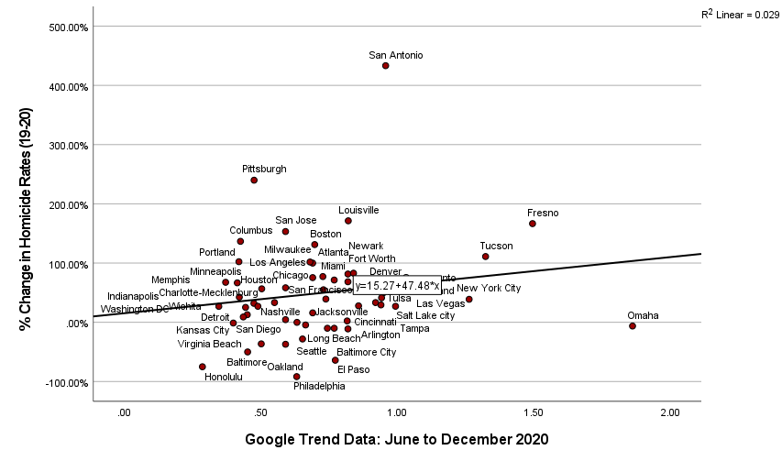

Figure #2 January to July 2021 Percent Change in Homicide rate by to Google Trend Ratio
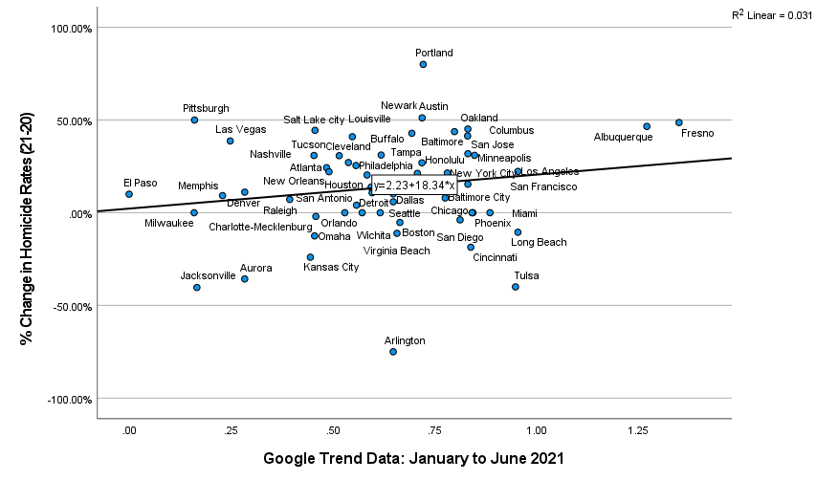

Figure #3 June to December 2020 Percent Change in Robbery rate by percentage in poverty
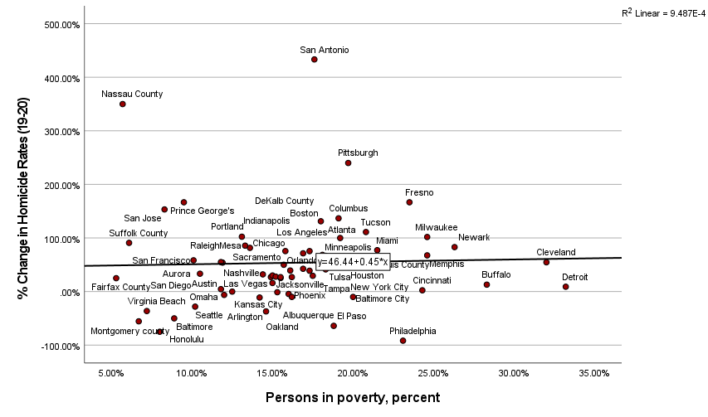

Figure #4 January to June 2021 Percent Change in Robbery rate by percentage in poverty

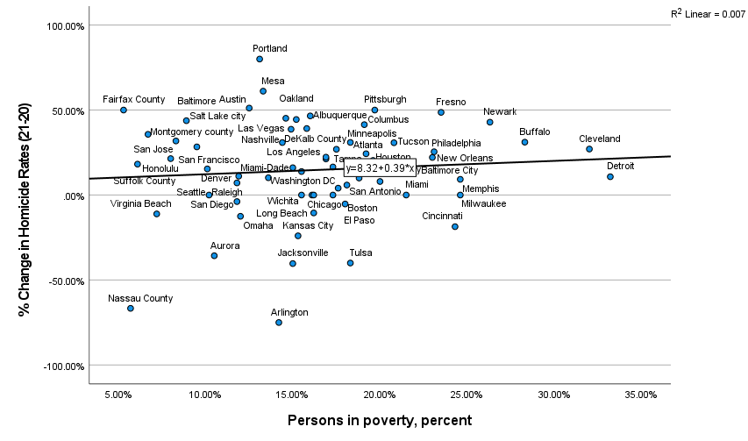

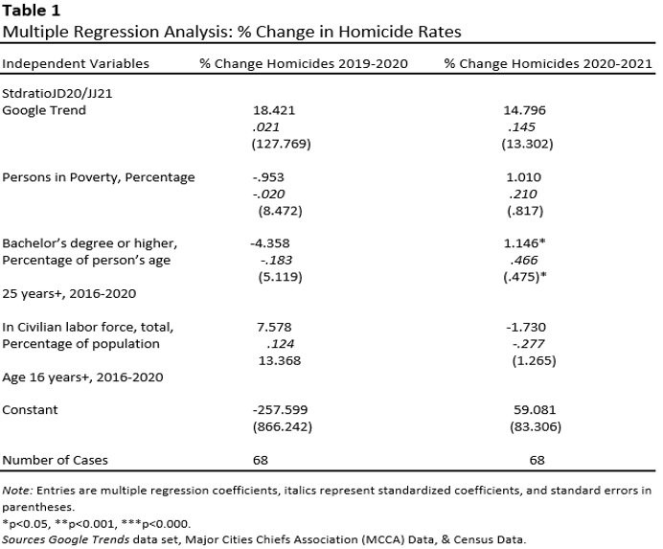

Figure #5 June to December 2020 Percent Change in Robbery rate by Google Trend ratio
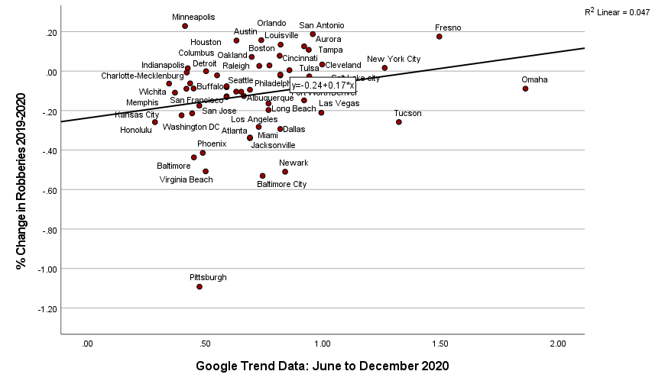

Figure #6 January to June 2021 Percent Change in Robbery rate by Google Trend ratio
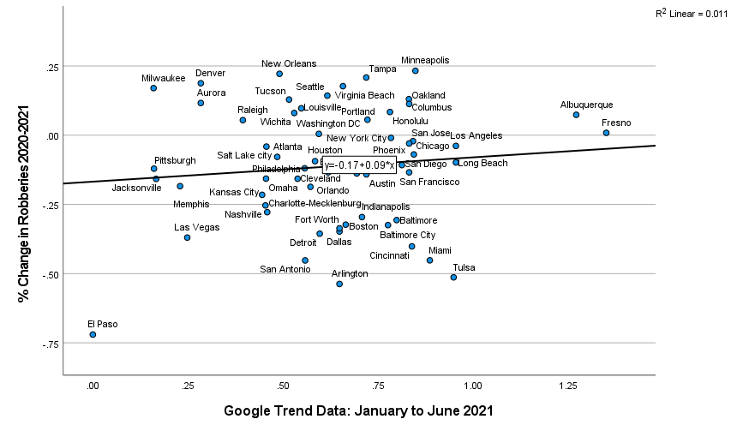

Figure #7 June to December 2020 Percent Change in Robbery rate by persons in poverty
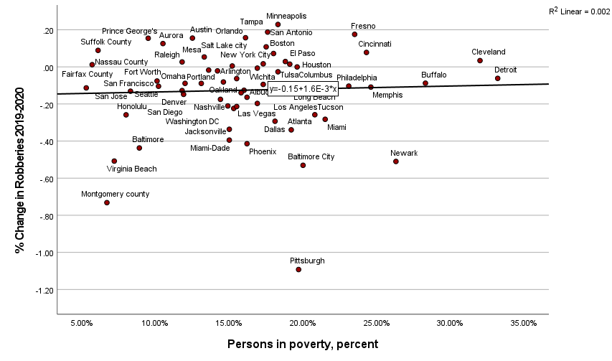

Figure #8 January to June 2021 Percent Change in Robbery rate by persons in poverty
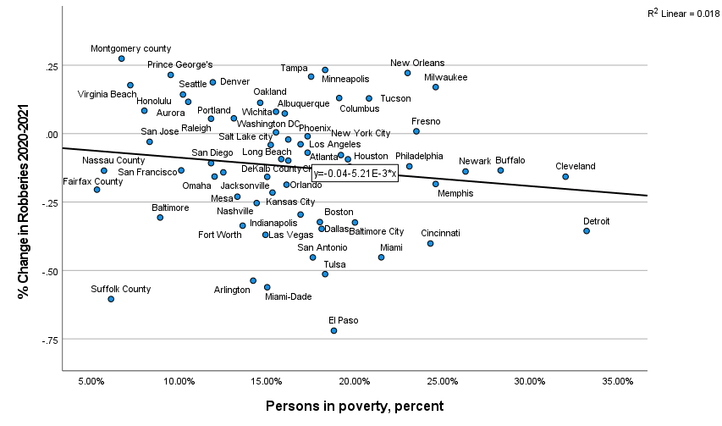

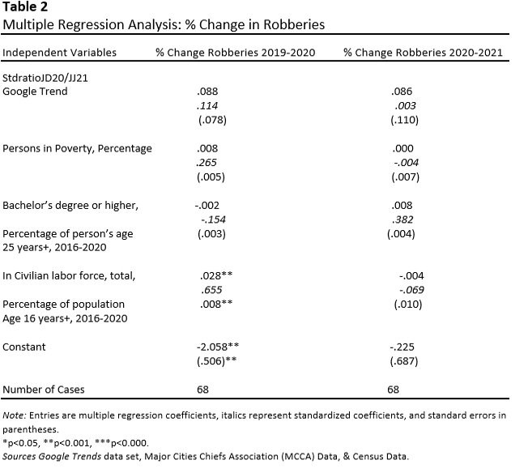

References
Antrobus, E., Bradford, B., Murphy, K., & Sargeant, E. (2015). Community Norms, Procedural Justice, and the Public’s Perceptions of Police Legitimacy. Journal of Contemporary Criminal Justice, 31(2), 151–170.
Brown, A. (2020, August 28). Wide partisan gap in views of police. Pew Research Center. Retrieved from https://www.pewresearch.org/fact-tank/2017/01/13/republicans-more-likely-than-democrats-to-have-confidence-in-police/.
Davis, R. C., & Hendricks, N. J. (2007). Immigrants and Law Enforcement: A Comparison of Native-Born and Foreign-Born Americans’ Opinions of the Police. International Review of Victimology, 14(1), 81–94.
Ekins, E. (2016). Policing In America [Review of Policing In America]. In CatoInstitute.org. Cato Institute. https://www.cato.org/survey-reports/policing-america-understanding-public-attitudes-toward-police-results-national#americans-are-not-anti-cop
Google. “Google Trends.” Google Trends, 2018, trends.google.com/trends/?geo=US.
Gross, N., & Mann, M. (2017). Is There a “Ferguson Effect?” Google Searches, Concern about Police Violence, and Crime in U.S. Cities, 2014–2016. Socius.
Hagan, J., Shedd, C., & Payne, M. R. (2005). Race, Ethnicity, and Youth Perceptions of Criminal Injustice. American Sociological Review, 70(3), 381–407.
Hinds, L. (2009). Public Satisfaction with Police: The Influence of General Attitudes and Police-Citizen Encounters. International Journal of Police Science & Management, 11(1), 54–66.
Lipson, C. (2021, August 9). Democrats' defund-the-police debacle. RealClearPolitics. Retrieved from https://www.realclearpolitics.com/articles/2021/08/09/democrats_defund-the-police_debacle_146216.html.
Maciag, M. (2021, June 14). Is there really a 'Ferguson effect'? Governing The Future of State and Localities. Retrieved from https://www.governing.com/archive/gov-ferguson-effect-homicide-rates.html.
Maxson, C., Hennigan, K., & Sloane, D. C. (2003). Factors That Influence Public Opinion of the Police. In nij.ojp.gov. NIJ. https://nij.ojp.gov/library/publications/factors-influence-public-opinion-police

Patten, E. (2013, August 28). The black-white and urban-rural divides in perceptions of racial fairness. Pew Research Center; Pew Research Center. https://www.pewresearch.org/fact tank/2013/08/28/the-black-white-and-urban-rural-divides-in-perceptions-of-racial-fairness/
“Resources – MCCA.” Major Cities Chiefs Police Association, majorcitieschiefs.com/resources/.Accessed 14 Apr. 2022.
Stewart, e.a., Baumert, e.p., Brunson, r.k. and Simons, r.l. (2009), neighborhood racial context and perceptions of police-based racial discrimination among black youth. criminology, 47: 847-887. https://doi.org/10.1111/j.1745-9125.2009.00159.x

United States Census Bureau. “Explore Census Data.” Census.gov, 2020, data.census.gov/cedsci/.
Vigne, N., Fontaine, J., & Dwivedi, A. (2017). How Do People in High-Crime, Low-Income Communities View the Police? https://www.urban.org/sites/default/files/publication/88476/how_do_people_in_high-crime_view_the_police.pdf

Wihbey, J., March 26, T. J. R., & 2012. (2012, March 26). Neighborhood racial context and perceptions of police-based discrimination. The Journalist’s Resource. https://journalistsresource.org/politics-and-government/neighborhood-racial-context-police-discrimination-black-youth/
White, M. D., Mulvey, P., & Dario, L. M. (2016). Arrestees’ Perceptions of the Police: Exploring Procedural Justice, Legitimacy, and Willingness to Cooperate With Police Across Offender Types. Criminal Justice and Behavior, 43(3), 343–364

