School of Graduate Studies
Bemidji State University
1500 Birchmont Dr NE, #48
Bemidji, MN 56601-2699
218-755-2027

INTERACTIVE WHITE BOARDS
IN A SECONDARY MATHEMATICS CLASSROOM

by

LeAnn Bolhuis

____________________

A Formal Portfolio Submitted to the Faculty of the
DEPARTMENT OF MATHEMATICS & COMPUTER SCIENCE

In Partial Fulfillment of the Requirements
For the Degree of

MASTER OF SCIENCE IN MATHEMATICS

BEMIDJI STATE UNIVERSITY
Bemidji, Minnesota, USA

November 2022

Copyright 2022 by LeAnn Bolhuis

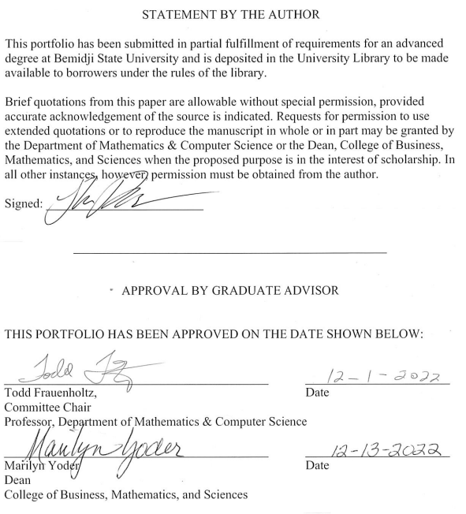

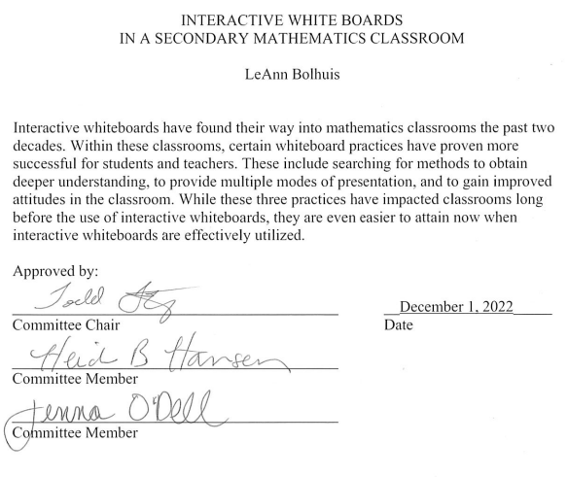

ACKNOWLEDGMENTS

I would first like to acknowledge my professors Todd Frauenholtz, Heidi Hansen, and Jenna O’Dell who have helped and guided me through this entire process.

The second person I would like to mention is my husband Dylan Bolhuis who took on extra responsibilities around the house with our two children Alice (3) and Remi (1) to make sure everything didn’t fall apart so I could complete this paper.

I would also like to mention every babysitter that took care of my children to give me time to work on this paper. These people would be Tammi Hanks, Jenna Chandler, and Tilly Chandler.

A special thanks goes out to my dad, Matthew Washenberger, my colleague, Juleen Trisko-Schneider, and friends Amanda Armstrong and Shouvik Bhattacharya who took time out of their lives to read through this paper to give me feedback throughout the entire process.

I would like to thank MacKenzie Lehn for also reading through my paper, giving me feedback, and supporting me through this process.

My students deserve some acknowledgement as well for being patient during my portfolio and giving me incredible feedback which I will use for years to come in order to become a better teacher.

Lastly, I would like to thank my children Alice and Remi. You have been my inspiration this entire time. All of this is for you to hopefully build you the life you deserve.

TABLE OF CONTENTS

Chapter Page

1. Introduction 1

2. Review of the Literature
Higher-Level Learning and Teaching 3
Multiple Modes of Presentation 11
Attitude 15
Summary Statement 17

3. Analysis
Similarities and Differences 19
Summary Statement 22

4. Portfolio Interpretation
Methods 24
Results 26
Summary Statement 28

5. Discussion and Conclusion
Discussion (Interpret the results) 29
Conclusion (Implications of the results) 30
Summary Statement 31

References 32

Appendix A. Rational Numbers Lesson Plans 36

Appendix B. Pre and Post Test 44

Appendix C. Raw Data 48

Appendix D. Statistical Calculations and Results 50

Chapter 1: Introduction

Introduction
Teaching has come a long way from chalk, blackboards and individual student slates. Each new invention – the mimeograph, the slide projector, the computer – enhanced instruction. In the last decade, technology has provided opportunities to change the method of teaching significantly. Therefore, it is natural that the use of technology by educators is a must. One of the recent advancements to educational technology has been the Interactive Whiteboard (IWB). IWBs have the capability to transform any classroom into a highly engaged, motivated and interactive environment. Integrating technology is important for today’s students because they have grown up in a digital age (Spears, 2011). Some might even argue that incorporating technology is a necessary condition for learning now since today’s students are so accustomed to technology. In this portfolio, I will explore the important aspects IWBs bring to a mathematics classroom, the best practices for using an IWB, and whether teacher and student attitudes change with the use of an IWB. The knowledge gained through this literature research will be used to determine the important qualities that make for the best use of an IWB within a secondary mathematics classroom and how these will be implemented into my own classroom. The data from implementing changes will be analyzed to determine whether findings match the research in the literature review. From that, I will determine what adjustments to make in the future to become a better teacher and also be able to utilize the IWB to its fullest potential. Through this research I plan to unearth the answer to the question, how should an IWB be used within a secondary mathematics classroom to be utilized best as an educational tool? This will in turn, highlight the best aspects an IWB holds in reference to teaching mathematics. Since I started teaching, I have had some type of IWB to use but I have always felt like I was using it as a glorified whiteboard. The goal is to understand what has been lacking in my lessons in regards to the IWB use in order to better serve my students. The focus of this portfolio will be aimed at how to reach higher-level learning, how the use of multiple modes of representation is used in regards to an IWB, and how attitude towards and because of the IWB changes learning within a secondary mathematics classroom.

Chapter 2: Review of the Literature

Introduction
When discussing Interactive Whiteboards (IWB), through my research three main themes became prevalent for teaching in a mathematics classroom; the aim for higher-level learning (Degenhart, Wingenbach, Dooley, Lindner, Mowen, & Johnson, 2007; Glover, Miller, Averis, & Door, 2007; Goos & Bennison, 2008; Serow & Callingham, 2008; Önal, 2017; Polly, 2014; Spears, 2011), the need to provide multiple modes of representation (Glover, Miller, Averis, & Door, 2007; Goos & Bennison, 2008; Polly, 2014; Akkaya, 2016; Spears, 2011; Holmes, 2009; Huleihil, 2017), and the attitudes of both the teacher and the students (Akkaya, 2016; Degenhart, Wingenbach, Dooley, Lindner, Mowen, & Johnson, 2007; Holmes, 2009; Letwinsky, 2017; Önal, 2017; Spears, 2011; Tatar, Zengin, & Kağızmanlı, 2015). An IWB alone will not provide these components. It is the way the teacher and students are able to interact with mathematics, using the IWB, that creates the possibilities for greater educational experiences. This requires a teacher to provide well thought out lessons that include interactive and engaging resources to get the students actively involved in their own educational experiences.
Higher-Level Learning and Teaching
The capabilities IWBs provide in mathematics classrooms are vast, but as teachers, it is necessary to explore all potential uses in order to fully benefit our students' educational experiences. Spears (2011) conducted a study on 247 seventh grade students in the 2008–2009 school year. To determine whether there was significant improvement in their learning, Spears (2011) created a pretest to administer at the beginning of the year followed by a posttest for the end of the year. Spears’ study sought to understand the impact IWBs, more specifically SMARTBoards, had on students learning mathematics (Spears 2011). She found that teaching with the SMARTBoard, which is a brand of IWB, made students more engaged and excited about learning. In addition, she examined scores from the MAP test administered to her seventh graders and compared these results to two other classrooms. One classroom which only used dry-erase boards, while the other classroom used an overhead projector. The results of this study showed that Spears IWB based classroom had the highest MAP scores with the greatest increase at the end of the school year in comparison to the dry-erase and overhead projector classes (Spears, 2011).
Similar findings were seen by Glover, Miller, Averis, and Door (2007) in their study performed on 36 teachers (24 mathematics and 12 foreign languages), from 12 different secondary schools in England. Glover et al. (2007) found the interactive approach provided by the IWB expands students' learning by challenging them to think in a variety of verbal, visual, and kinesthetic ways. They observed that through the enhanced interactivity, more understanding and learning was formed. This was witnessed through students' ability to recall information and by linking past material to new material. It allowed cognitive development of the topic and students were able to actively learn through different forms of stimuli presented by the IWB. In these lessons “the IWB was used to prompt discussion, explain processes, develop hypotheses or structures, and then test these by varied applications” (Glover et al., 2007, p. 10). Through this study Glover et al. (2007) discovered it is still the quality of teaching that provides students with higher-level learning, the IWB alone does not guarantee it.
Polly (2014) did a similar study that observed one third grade teacher and two fourth grade teachers and how they used different forms of technology within their mathematics classrooms. Through this, Polly looked for lessons with the most high-level tasks and determined which forms of technology were prominently used. The tasks, for which the students used iPads, were primarily independent memorization type tasks without any teacher supervision (Polly, 2014). In each observation, the document camera was used to project tasks, and in some cases student work. In this instance, the document camera was used to display tasks, so it would not be labeled as low or high level considering it is only used as a display tool. Meanwhile, in the lessons observed that contained the IWB, teachers and students tended to use exploratory activities including high amounts of interactivity from the students. According to Polly (2014), these types of lessons were coded as high-level tasks. In other words, the IWBs were the only form of technology witnessed by Polly (2014) that used high-level tasks. Within these limited number of IWB high-level lessons, Polly (2014) noticed students were provided multiple representations through the IWB to assist in learning.
Serow and Callingham (2008) also did a study analyzing the use of IWBs and iPads within three different classrooms differing in experience. In this year-long Australian study, the three teachers, fourth, fifth, and sixth grade, from different schools in the state of Victoria, Australia were observed during their lessons that involved either the iPads or IWBs. Through this study, the fourth-grade teacher was able to provide students with an engaging, collaborative lesson using the iPads. The fifth-grade teacher also used the iPad but it was used in a discovery sense where students would look at geometric shapes and identify properties. This project's end product was less intuitive than expected. More direction was potentially needed to have the results this teacher was seeking (Serow & Callingham, 2008). The sixth-grade teacher used the IWB more than the iPads and, opposed to other research, this teacher found a disconnect with deeper understanding when he used the IWB (Serow & Callingham, 2008). The lesson in which this was recognized involved the sixth-grade teacher using geometric shapes to construct tessellations. As Serow and Callingham (2008) stated:
this provided a digital mimicry of the use of pattern blocks and did not seem to lead to a deeper understanding of the conditions under which a shape would tessellate. Such use locks students into lower levels of thinking, but this may also have been reinforced by the teachers’ own perceived lack of knowledge (p. 457)
From this, Serow and Callingham (2008) summarize that there was an increase in motivation from students with the use of an IWB. It also sparked encouragement and interested in the content. Although, this was only present during well thought out and executed lessons. Without careful planning along with pedagogy, the benefits that the IWB possess are diminished and students learning was not enhanced nor gains from students increased interest.
Önal (2017) found the majority of the 58 interviewed fifth through eighth grade students at the Ministry of National Education in Turkey perceived the IWBs as beneficial to their learning. They mentioned the following benefits as helpful; giving different representations, splitting up the teacher’s job, system characteristics, visual, touch screen, and the lessons were more seamless (Önal, 2017). As for the lessons, students said the IWB provided a meaningful way to learn, increased motivation and understanding, improved students' achievement and attitudes towards mathematics, they were able to confidently solve more problems, and solve problems more in depth (Önal, 2017).
Goos and Bennison (2008) surveyed secondary teachers and administration in Queensland, Australia.
Technology helps perform calculations more quickly and easily | Agree  Strongly Agree | 94%
Technology provides dynamic feedback to students | Agree  Strongly Agree | 93%
Technology enables to study of real-life applications. | Agree  Strongly Agree | 83%
Table 1: Results from Goos and Bennison (2008) Survey
Goos and Bennison (2008) also noticed a trend in the teacher and administrator responses suggesting they were unsure whether the use of technology erodes students' basic mathematics skills (26.8%). As for students understanding mathematics at a deeper level, Goos & Bennison (2008) found from the responses that 79.8% of teachers stated technology helps students see links between different representations and 70.6% stated technology makes sophisticated mathematical topics accessible to students. Teachers mentioned the major obstacle for teaching with technology was lack of meaningful professional development. This was an issue because simply having the resources available does not mean higher-level teaching or learning is occurring (Goos & Bennison, 2008).
Akkaya (2016) conducted a study in Turkey investigating the changes in teachers' perceptions of teaching mathematics with the use of technology after training in technology integration in mathematics. Akkaya (2016) found pre-service teachers' perceptions of teaching mathematics with technology positively increased. For this research, technology was a broad term which the pre-service teacher used to pin-point specific types within specific areas of mathematics. For example, they mentioned how geometry software is beneficial in representing the visual aspects and gives students the ability to manipulate the objects. Computer assisted programs such as GeoGebra and Cabri-Geomerty were also mentioned as ways to break the monotony of paper assignments. Pre-service teachers' perception of the requirement of technology to teach mathematics increased as their perceptions of the advantages that technology provided in the teaching of mathematics increased. The perceptions of the disadvantages created by the use of technology in teaching mathematics was unaffected by the intervention. Akkaya (2016) found that pre-service teachers found several disadvantages to the use of technology for teaching mathematics. It creates extra work for the teachers, some students dislike technology therefore the implementation of technology to teach will disengage these students, and the biggest complaint was the lack of useful technological materials and tools in order to teach effectively. The highest percentage of pre-service teachers' answers fell into the requirement category which indicated these teachers felt technology was a requirement to teach mathematics. Forty percent of these teachers believe teaching method is the biggest factor on the use of technology within a mathematics classroom. Akkaya (2016) looked more deeply into this category, teacher perceptions of mathematics, to find the pre-service teachers believe technology provides students with more opportunities by these teaching methods. Also, it is used to draw attention to the lessons and allows for a constructive learning environment.
Degenhart, Wingenbach, Dooley, Lindner, Mowen, and Johnson (2007) conducted a different type of study analyzing the effects of middle school students' attitude towards STEM (Science, Technology, Engineering, and Mathematics) provided a positive influence from a National Science Foundation (NSF) Graduate Fellow. This NSF Graduate Fellow helped teach and provided interactive learned-centered lessons throughout the span of one school year. The goal of this study was to determine what interested students in STEM topics and what motivated them to go into STEM careers. Data were collected as a pre/post survey on students' opinions about STEM (Degenhart et al., 2007). Degenhart et al.’s (2007) main question was whether students believed they could become a scientist (technologist, engineer, or mathematician) like the NSF Graduate Fellow. This study showed what motivates students to strive in STEM related careers and these hands-on, student-centered lessons has an overlap with how to successfully integrate an IWB into teaching. Results from students’ about whether they perceive themselves capable of pursuing a career in STEM can be found in Table 2.
Remain Negative | 64.4%
Remained Positive | 12.9%
Remained Uncertain | 1.1%
Positive to Uncertain | 2.4%
Positive to Negative | 10.2%
Negative or Uncertain to Positive | 9.3%
Negative to Uncertain | 3%
Table 2: Students’ Opinion from Pre to Post Survey Results on STEM Professions
While there was a large amount of negative feedback, the focus became on the 9.3% of students whose opinions on whether they could become a STEM professional like their NSF Graduate Fellow increased (Degenhart et al., 2007). What happened to these students to change their opinions? From the surveys, Degenhart et al., (2007) determined students became more motivated and enthusiastic towards a subject for which they have a positive belief of self-efficacy. Considering, people place higher value on things they believe they are able to accomplish, teachers need to frequently implement authentic activities to reinforce positive self-efficacy for their students (Degenhart et al., 2007).
As previous studies suggested, this is what IWBs are completely capable of when implemented in an engaging, student-centered, and interactive approach.
Huleihil (2017) conducted a research study involving the Computer-Aided Design (CAD) process; design on paper, CAD design and manufacturing, on sixth grade students in Israel. Through this the researcher studied whether the hands-on visual process CAD provides makes an impact on students' understanding. IWBs are not CAD, but with the types of interactive software they have built in, a similar experience is possible in an IWB classroom. The sixth-graders were split into a reference group and an intervention group. These two groups were given the same three exams throughout the school year to compare results and determine effects of the three-dimensional software and CAD process. Through the three terms, A, B, and C, the intervention group consistently scored higher on the exams.

Term A | Reference Group | 50.3
 | Intervention Group | 56.5
Term B | Reference Group | 54.7
 | Intervention Group | 61.5
Term C | Reference Group | 55.2
 | Intervention Group | 75.0
Table 3: Mean Test Scores at the End of Each Term
From this Hulihil (2017) saw that CAD made it possible to teach mathematics concepts and skills through geometric construction and modeling, which was self-exploratory for students. Clearly, through the exam results, this method of teaching provided the intervention group better understanding of the skills and concepts. Therefore, the style of teaching that CAD provided; hands-on, visual, and manipulative, should be the aim when using an IWB in order to resemble the successful CAD process within a mathematics classroom.
Multiple Modes of Representation
A common theme presented itself through the IWB studies analyzed which was the ability to use multiple modes of representation in teaching mathematics. Glover et al. (2007) found this within their study of IWB use within a mathematics classroom. Glover et al. (2007) noted that few teachers based all of their lessons solely on IWBs. The majority of the teachers interview stated that they see the IWB as part of the tools necessary for teaching but there is still a need for more traditional tools such as textbooks, worksheets, and physical manipulatives. The teachers stated that the tools they used to teach each lesson varied according to what method was best fitted. IWBs were not used unless the educational gain was recognized (Glover et al., 2007). Overall, Glover et al. (2007) recognized the need for enhanced interactivity for these students is necessary to gain the most knowledge and understanding of mathematical concepts. The best mathematics teachers realize the necessity for a balance between different modes of representation of the mathematics topics in order to reach a wider range of students. Multiple modes of representation are used in order to give each of the four learning styles (visual, rote, audio, and kinesthetic) the chance to understand the lesson they work best with. Typically, the kinesthetic learning is lacking which is why including more interactivity within lessons is necessary. Glover et al. (2007) also mentioned that more thought out pre-planning by teachers when designing activities helps build on the use of verbal, visual, and kinesthetic approaches. Creating lessons with a variety of ways to learn the material provides students the most opportunities to deeply understand the concepts. Spears (2011) says that students tend to learn in multiple ways simultaneously. While generally students have one major learning style that they excel at, they are still gaining information while others are present. For example, while students are writing information down from the board, they are hearing the teacher read and explain. From this, students are able to link what they are writing to what the teacher is saying. To take it further, having an image or visual aid of the concept with give students the visual component to link with. Then to top it off, after students have an idea of what they are learning about, building in an activity where students physically manipulate the concepts will bring in the kinesthetic learners while creating a more real-world situation. With the IWB in Spears’ (2011) saw that students were able to engage and interact more and in different ways than before. Spears stated (2011) students right now, who she calls Digital Natives, need to be actively engaged to learn. With the IWB “the students were always engaged in the lesson and active in many components of the lesson in ways that would not be possible with a chalkboard, dry-erase board, or an overhead projector” (Spears, 2011, p. 132). Spears (2011) found that to give students the best educational experiences, using the IWB was to give students each mode of learning (visual, auditory, kinesthetic, and rote) within each lesson. This will give them the greatest opportunity to gain the knowledge provided. On top of that, educators need to find ways to allow students to take charge of their educational experiences. Holmes' (2009) study found teachers understand the need for alternate forms of representation. As mentioned by Holmes (2009) subjects identified various benefits of using an IWB, namely they provide whole class presentations, a variety of representations, cater to multiple learning styles, address classroom management issues by capturing and holding students’ attention, increased student motivation, and they are able to move at a faster pace due to pre-prepared lessons. Akkaya’s (2016) pre-service teachers agree that technology has many advantages for teachers. They recognize that through the use of technology, teachers are able to bring in more visual learning along with other methods of teaching. With this, increases students’ motivation, makes lessons more fun, provides learning opportunities to multiple senses, and saves time.
Huleihil’s (2017) mentioned this method of teaching with CAD was a success considering the multiple forms of learning involved within the three-dimensional printing process. The CAD process includes three steps: design on paper, CAD design or creating it digitally, and the manufacturing or creating the physical model. The design process, both on paper and CAD, give students a different way to learn mathematical concepts and skills through construction. Then to check their work, they can manufacture their projects. This gives students something physical to analyze to interpret whether their original design was correct. If something went wrong, students are given the opportunity to troubleshoot the issue by looking back at their design process and adjust. This process is how teachers should be implementing IWBs in teaching mathematics (Spears, 2011; Holmes, 209; Glover et al., 2007; Akkaya, 2016). As Huleihil (2017) put it, this type of technique creates more enthusiasm to participate in class and students’ spatial imaginations are effectively stimulated.
Goos and Bennison (2008) noticed there was a common theme among their returned surveys which was that the teachers stated the technology allows students to explore different mathematics topics, therefore increasing students’ abilities. Seventy three percent of the replies agreed or strongly agreed technology helps students explore unfamiliar problems. It is also noted eighty-three percent perceived technology to provide students with more real-life applications. In his study Polly (2011) noticed when teachers implemented internet-based activities on the interactive whiteboard, they always kept the whole class together, and either the teacher or students used it to manipulate the objects or write on. The aim for mathematics teachers is to have highly cognitive lessons. When the IWBs were utilized, this was the majority of the lessons. Along with the IWB though, the teacher would provide students multiple ways to learn the material such as paper and pencil but also interactive manipulatives presented on the IWB (Polly, 2011). Having multiple ways for students to understand a concept will only benefit students by providing them more opportunities to learn. This means both by aiming lessons at the four different learning styles; visual, auditory, kinesthetic, and rote, but also having a balance between how and when to use technology such as IWBs.
Attitude
The attitude a teacher brings to a classroom can completely alter the dynamic of the room the same way a student's attitude can completely change that student’s and others' outlooks on the class itself. Önal (2017) found in his study that the students enjoyed using the interactive whiteboards. They believe that it helps them understand the material better and faster by providing meaningful lessons. One student was even quoted saying, “[IWBs] had a positive impact. Mathematics is more fun now. I started to better understand the subjects, which I couldn't before in the mathematics classroom.” Another student mentioned the use of an IWB increased their motivation towards the class because it made class more fun and easier to understand (Önal, 2017). It was also mentioned by Önal’s (2017) students that the IWB has encouraged them to participate more and they are now excited to solve problems on the IWB on their own.
Serow and Callingham (2008) noticed when students used the iPads or IWBs they were more engaged, motivated, and found learning to be fun and interesting. Spears (2011) had similar findings where she noticed that when she taught with the SMARTBoard students were more engaged than her previous year with the chalkboard. The students were able to interact now with the mathematics lessons in a fun way for possibly their first time ever (Spears, 2011). Although a professor did mention to Spears (2011) her students might have scored better on the posttest and MAP test regardless due to the excitement she brought to teaching because of the SMARTBoard. Her attitude towards using the SMARTBoard in teaching mathematics was a possible contributor to her students' success as well as their attitudes toward the class itself.
Goos and Bennison (2008) found in their survey sixty-one percent of teachers who replied stated technology improved students' attitudes toward mathematics. As Degenhart et al. (2007) also noted these positive attitudes toward mathematics come from self-efficacy or believing in oneself. In order for mathematics teachers to lead students toward this, students need to gain confidence in themselves when it comes to mathematics, which means, teaching involving self-exploration, involvement, and inquiry-based teaching.
Akkaya (2016) noticed an attitude change within his study where pre-service teachers gained a more positive attitude toward the use of technology after being immersed in it and realizing its capabilities. “Teacher perception towards technology is a factor that determines technology use” (Akkaya, 2016, p. 862). This led into Letwinsky’s (2017) findings that nearly half of the participants used what they know of technology for teaching and about three quarters of the participants indicated they enjoyed using technology to teach. The determining factor on whether these teachers utilized technology within their classrooms was their self-efficacy towards technology use. If they had high self-efficacy then their attitudes toward using technology was also high (Letwinsky, 2017). Akkaya (2016) found this is the leading factor on whether technology is used in teaching or not. Tatar, Zengin, and Kağızmanlı (2015) observed this same phenomenon in their study on teachers' attitudes toward technology pertaining to 481 elementary and pre-service mathematics teachers in Turkey. As Tatar, Zengin, and Kağızmanlı (2015) observed pre-service teachers who had positive perceptions of the advantages and requirements of technology use had lower anxiety while teaching mathematics. This was also the case when analyzing pre-services teachers’ perceptions regarding technology use in teaching mathematics. Considering pre-service mathematics teachers anxiety decreases as their technology perceptions increase, prioritizing technology training in the teacher training process and providing up-to-date software will help contribute to decreasing teacher anxiety (Tatar, Zengin, & Kağızmanlı, 2015)
Holmes (2009) noticed the use of an IWB aided with classroom management since the students are more engaged, motivated, and involved. He also warns of the potential for a decrease in excitement regarding the IWB use. As one of Holmes’ (2009) students stated in the survey, replacing repetitive chalk and talk lessons with repetitive interactive lessons will cause students to disengage with learning. Therefore, the attitude a teacher brings to the classroom can alter students' outlooks on the class. On the other hand, striving to bring high self-efficacy to students towards their mathematics skills might bring greater long-term effects to students' mathematical abilities and attitudes toward the subject in general.
Summary Statement
IWBs are a widely used tool being provided to mathematics teachers around the globe. As mentioned, just having an IWB does not provide students with the types of educational experiences they require to maximize students’ mathematical understanding. Teachers need to find a balance between the use of the IWB, paper and pencil, manipulatives, and other modes of representation to reach as many students as possible (e.g., Glover, Miller, Averis, & Door, 2007; Goos & Bennison, 2008; Polly, 2014; Akkaya, 2016; Spears, 2011; Holmes, 2009; Huleihil, 2017).
Teachers also need to be familiar with the many ways to use an IWB. To get the best use out of the features and capabilities of the IWB, a teacher must plan to incorporate seamless interactivity. If done correctly, students will be provided with lessons that lead them into higher-level thinking when it comes to mathematics (e.g., Akkaya, 2016; Degenhart, Wingenbach, Dooley, Lindner, Mowen, & Johnson, 2007; Glover, Miller, Averis, & Door, 2007; Goos & Bennison, 2008; Serow & Callingham, 2008; Önal, 2017; Polly, 2014; Huleihil, 2017; Spears, 2011).
Ultimately, the goal of mathematics teachers is to grow their students' knowledge and understanding beyond base knowledge. One of the largest driving factors found was the attitude the teacher brings to the classroom and the teacher’s attitude towards the use of technology while teaching mathematics (e.g., Akkaya, 2016; Degenhart, Wingenbach, Dooley, Lindner, Mowen, & Johnson, 2007; Goos & Bennison, 2008; Holmes, 2009; Letwinsky, 2017; Önal, 2017; Spears, 2011; Serow & Callingham, 2008; Tatar, Zengin, & Kağızmanlı, 2015). Student attitudes are at least as important as teacher attitudes, if not more, as to how they affect the learning of mathematics. A teacher's attitude can enhance student attitudes toward a positive perception of their abilities to learn mathematics. Essentially, when a student is confident in their ability to accomplish the mathematical tasks at hand, they will be more successful and will enjoy mathematics. Therefore, in order to build great mathematics students, the focus should be to provide them with attainable, discovery mathematics that will make the process authentic and enjoyable.

Chapter 3: Analysis

Introduction
Certain patterns were noticed throughout this literature review in association with teaching in a mathematics classroom including an IWB. First, the utilization of an IWB within a mathematics classroom provides students with unique ways of gaining higher-level learning by providing lessons that develop deeper understanding (Goos & Bennison, 2008; Serow & Callingham, 2008; Önal, 2017; Polly, 2014; Huleihil, 2017). Second, the IWB allowed for alternate representations that were difficult to produce with typical forms of teaching (Glover, Miller, Averis, & Door, 2007; Polly, 2014; Akkaya, 2016; Spears, 2011; Holmes, 2009; Huleihil, 2017). Lastly, the attitude of students and teachers change with using an IWB in the mathematics classroom (Tatar, Zengin, & Kağızmanlı,2015; Letwinsky, 2017; Degenhart, Wingenbach, Dooley, Lindner, Mowen, & Johnson, 2007; Goos & Bennison, 2008; Serow & Callingham, 2008; Önal, 2017). Both teacher and student seem to enjoy the lessons more and because of that, they gain more from each lesson. Within this analysis, I will highlight the main points found from each of the sources which guided me to the themes mentioned.
Similarities and Differences
Each one of the sources in the literature review had their own findings of what was most important in relation to using technology or an IWB when teaching mathematics. Spears (2011) decided incorporating interactivity, along with student-centered learning, creates the best learning environment for her students. Glover et al. (2007) felt the same way, going on to say that lessons involving teacher-centered learning are very limiting. With the student-centered lessons including interactivity, students’ cognitive development regarding mathematics is harnessed (Glover et al, 2007). Polly (2014) agreed the learner-centered pedagogies provide students with opportunities for higher-level thinking.
Serow and Callingham (2008) also found technology provides students with deeper thinking opportunities and more connections. They found lessons were more engaging, which increased students' motivation. Önal (2017) found similar results stating students were able to achieve higher scores using an IWB because they found it to be more enjoyable. Students stated they were able to go farther into mathematics problems and fully understand them with the help of the IWB (Önal, 2017). Goos and Bennison (2008) also found similar results, stating IWBs increase students' abilities to explore different mathematics topics.
Akkaya (2016) found when using technology and IWBs the teachers were able to provide students with non-traditional forms of learning, which gave students more opportunities to learn through exploration and interactive lessons within a student-centered environment. This positively affected students' perceptions of mathematics and the content they were learning (Akkaya, 2016). Degenhart et al. (2007) found students who were provided practical learning experiences tended to enjoy the topic at a greater level and perceived this was something they were capable of doing. Huleihil (2017) noticed that through the three-dimensional modeling techniques, students gained deeper understanding of the geometric concepts they were learning.
Not every student is the same and this affects how they learn. Through this research I found multiple representations of a mathematical concept prove effective in successfully teaching students (e.g., Huleihil, 2017; Holmes, 2009; Akkaya, 2016). These sources found, with the use of IWBs, students were provided two methods of learning that are typically neglected; visual and kinesthetic. This benefitted every student, even those who learn best through rote and audio because they were provided with lessons that accessed all their senses. An increase in engagement and enjoyment of mathematics was also witnessed with the use of an IWB (e.g., Polly, 2014; Spears, 2011; Goos & Bennison, 2008; Glover et al., 2007). Along these same lines, the researchers found different methods were used simultaneously to teach a lesson. This included technology but also pencil and paper, manipulatives, and even textbooks. The wide range of learning techniques provided students with the ability to learn in the way they are most comfortable, which leads to higher achievement in mathematical learning.
The attitudes students and teachers brought to the classroom were found to be contributing factors on how the class was going to operate. Some researchers found students’ attitudes towards mathematics became more positive with the use of IWBs (e.g., Önal, 2017; Serow & Callingham, 2008; Spears, 2011; Goos & Bennison, 2008; Akkaya, 2016). With these positive attitudes towards mathematics, students tended to be more motivated, engaged, and found joy in the lessons. Others found self-efficacy was the driving factor on whether students were successful in mathematics (e.g., Tatar, Zengin, & Kağızmanlı, 2015; Letwinsky, 2017; Degenhart et al., 2007). Through the use of IWBs and the perception of mathematics in regard to the IWB, students’ and teachers' perceptions of their own capabilities improved which lead to improvement in the students’ mathematics skills and the teachers’ ability to successfully teach. Holmes (2009) found opposing results from the other sources stating the use of IWBs showed a decrease in excitement and achievement from the students.
I consider Spears’ (2011) yearlong research study the most relevant to my classroom; considering the demographic was Midwestern United States middle school students while she utilized an IWB. This is what my portfolio study is based on, but on a smaller scale. From her findings, I believe that student-centered learning is the best way to reach higher-level understanding within my classroom. These lessons need to be engaging and interactive. Also, the research from Glover et al. (2007), Holmes (2009), Polly (2014), and Akkaya (2016) showed teacher-centered learning is not recommended, which supports Spears’ (2011) findings, but I find it important for my own classroom to create lessons with multiple modes of representation and in order to do that, I will need more thorough planning.
Lastly, from this research, I believe that my attitude as a teacher is something I can control to create a better learning experience and environment for my students. My attitude alone can help change whether students believe in themselves and enjoy mathematics (e.g., Akkaya, 2016; Goos & Bennison, 2008; Tatar, Zengin & Kağızmanlı, 2015; Letwinsky, 2017; Önal, 2017). The researchers found students' attitudes towards IWBs affects their enjoyment and understanding of mathematics but that is something I have less control over.
Summary Statement
Many findings were mentioned from each of the sources provided. I have summarized the main points into the main themes to implement into my classroom. These include:
- Student-centered lessons to give students the best opportunities for higher-level thinking;
- Multiple forms of representation when teaching to provide opportunities for each learning style to understand the material;
- Teacher attitude affects teachers’ ability to teach and students attitude towards learning and mathematics.
This will require me to better plan my lessons and include multiple representations to reach every student in every learning style. On top of all of this, I have decided that I cannot control the attitudes of my students or anyone else, but I do have control of my own attitude. From this research, the attitude of the teacher is enough to change students' outlooks on mathematics and can create more enjoyable experiences for teacher and students. These adjustments to my classroom will be my next steps.

Chapter 4: Portfolio Interpretation
Introduction
During my literature review, I became interested in doing some of my own research. I would like to see the impact IWBs have on teaching and learning within my mathematics classroom. My goal was to find as many unique and relevant ways to provide my students with the content I was teaching using the IWB as the centerpiece. From my research, I was hoping to recreate some of the scenarios previous researchers reported, such as increases in motivation, engagement, and learning due to the use of an IWB. With this, students would walk away with a better understanding of the topics, instead of simply being able to use them. I had three research questions I was trying to answer with this research:
- Do multiple forms of representation with the use of an IWB increase students understanding and retention?
- Does the implementation of an IWB help create deeper-level understanding?
- Does the teachers’ attitude towards the IWB create better attitudes in the students that increase understanding?
Methods
The portfolio study in this paper was on teaching lessons incorporating the IWB to become the center of attention during an entire seventh (19 students) and eighth grades (8 students) Pre-Algebra unit (see Appendix A for the lesson plans). The twelve-day unit was on Rational Numbers. During this unit, I created lessons that used the IWB as the main mode of information. This gave my students more hands-on, interactive, and visual ways of learning.
The students within these classes were from a rural town in northern Minnesota. Which means these classes contained the entire seventh-grade and eighth-grade classes, all ability levels were present in the one class. The demographics of the students was 23 white, 3 Native American, and 1 Asian. Of these students, 4 had IEPs. Fourteen of these students received extra help in mathematics from Math Corps.
At the beginning of the unit, students took a pre-test to have a baseline of where they were at with the topic of Rational Numbers. Then the lessons began. Each lesson involved a short introduction to the topic taught using slides on the IWB. Some lessons were completely interactive, where I would show a concept and then the students would try it on their own in the next slide. This would be accomplished by having multiple students come to the board to try problems out. A requirement I had was they needed to be able to explain the steps they took or had someone who could explain for them while doing the problems in front of the class. I noticed the eighth-grade class was a better at this than the seventh-grade class. With the interactive lessons, students' summative assessments were done during their interaction with the IWB. If the lesson was not interactive, it was a very short formal lesson, about five minutes long with guided notes. After the lesson, students would interact with the board by either displaying their work from their Chromebooks to the IWB, playing a game through the IWB, organizing numbers through a premade slide, or working on a displayed IWB problem on their desks via a whiteboard marker. They were then given a chance to write their final solution on the IWB. After the seven lessons of this unit were finished, students took a post-test to see how much they learned in comparison to their pre-test.
Students' pre-test and post-test scores were entered into Google Sheets document to analyze and organize the data. Students were assigned a number to keep anonymity and then lined up with their pre and posttest scores. To determine students who scored above 70% on the posttest, the percent increase equation was used. A TI-84 Graphing Calculator was then utilized to conduct further testing on the data to determine whether the results were statistically significant, which will be analyzed in the results section.
Prior to this, students had been taking notes and learning in a more traditional style in my class. Therefore, these lessons represented new and exciting experiences for them within my classroom. The assessments used were non-traditional. Students were able to show their understanding by fusing activities or games opposed to the traditional written assignments. This also increased engagement and decreased the number of missing assignments. Students were expected to participate with the games and activities, which they were more excited to do. Due to this, all their assignments were done with near perfect completion. As the unit went on, their excitement seemed to diminish. The constant use of the IWB was becoming less of a novelty.
Results:
My first null hypothesis was the pre-test score would be greater than or equal to the posttest score and the alternative hypothesis was that the posttest score would be greater than the pre-test score. This will determine whether the multiple representations used with implementing the IWB helped students understand and retain the lessons. Using a paired sample t-test, comparing the pre and post-test, the p-value of 0.00000000007835 indicated I was able to reject the null hypothesis and conclude the pre-test scores were not less than or equal to the post-test; therefore, student learning did occur. This tells me that using the IWB in different ways did help students understand and retain the information.
My second null hypothesis was that the mean of the posttest scores were going to be less than or equal to 70% and the alternative hypothesis was that the posttest score would be greater than 70%. This mean score will help determine whether students understood the material on a deeper-level. The class mean was 72% but to ensure that I was able to reject the null hypothesis I conducted a t-test on the post-test to come up with a p-value of 0.091, which indicated I failed to reject the null hypothesis stating the results were not statistically significant and the mean was not above 70% on the posttest. This indicates the students did not learn the material up to my expectation.
My third null hypothesis was 80% of the students would receive a score less than or equal to 70% on the posttest and the alternative hypothesis was that 80% of the students would receive a score greater than 70% on the posttest. Fifteen of the 27 (55.5%) students received a grade over 70%. This will show whether students increased attitude from the teachers increased attitude created better learning to occur. To check if this was statistically significant, I conducted a test of proportions which came out with a p-value of 0.999 which failed to reject the null hypothesis. These results were rather disappointing considering I was hoping for a statistically significant improvement in my students' knowledge. This does not show there was a gain in knowledge between the pre and posttest.
After the unit, I conducted an informal discussion with my students about what they enjoyed and what they did not. They commented the constant interactivity and change of pace every day was exciting. When I used the same Gimkit assessment a few days in a row they found it boring. Also, something I noticed during this portfolio is my students struggled taking the posttest. They mentioned it was more difficult to take this test than other tests I had administered during the school year. This is shown also by the results of my second and third hypotheses results not being statistically significant. The difference I noticed is that my assessments were non-formal while my post-test was formal. Hence, I was asking my students to display their knowledge in a different way than they practiced during the entire unit.
Summary Statement
During this portfolio I was able to recognize several patterns about the use of an IWB within a mathematics classroom. First, students developed a better understanding of the material provided with multiple modes of representation with an IWB. Although, deeper understanding appeared to occur considering the calculated mean score was above 70%, this was not statistically significant so I am not able to claim this happened. Lastly, though it is difficult to determine whether attitude effected students learning, though the tests that I conducted, this was shown not to occur. Students proved they learned through this technique by the statistics shown between their pre and posttests. On the other hand, students expressed certain changes they would hope for next time including the use of notes and more variability between activities and assessments. Also, in hindsight, my formative assessment should mirror the practice done during the summative assessment or vice versa.

Chapter 5: Discussion and Conclusion
Introduction
My portfolio study along with the literature review has taught me many new ways to become a better teacher. This includes ways to provide variability within my lessons, tests, assessments, and ultimately how the class is organized. Making these changes will improve the learning experience for students, increase student engagement, and help me grow to my fullest potential as a teacher.
Discussion
Through my process I was able to claim that multiple modes of representation did benefit my students academically. They proved that they understood and retained the material when I used the IWB in multiple different forms trying to access each learning style. This was witnessed as well by Glover et. al. (2007) Polly (2014) Akkaya, (2016) Spears (2011) Holmes (2009), and Huleihil (2017). I was able to see this when I compared how my students did on their pretest to posttest results.
My research claimed that implementing an IWB within a mathematics classroom would help students reach higher-level understanding and gain deeper meaning from the material (Goos & Bennison, 2008; Serow & Callingham, 2008; Önal, 2017; Polly, 2014; Huleihil, 2017). From my lessons, I aimed to reach this within my classroom as well. According to my results, this was not what I found though. The students in my classroom did not reach higher-level understanding that was statistically significant for the data.
Lastly, I wanted to test to see how attitude changed my classroom. According to the research, a teacher with a more positive attitude towards technology gains more positive attitudes from the students to learn. In turn, this creates a better learning environment for students and more success (Tatar, Zengin, & Kağızmanlı,2015; Letwinsky, 2017; Degenhart, Wingenbach, Dooley, Lindner, Mowen, & Johnson, 2007; Goos & Bennison, 2008; Serow & Callingham, 2008; Önal, 2017). I found this to be difficult to tests but my results indicated that this was not a success considering students did not achieve as high of scores as I predicted they would.
Conclusion
Since the multiple forms of representation while implementing an IWB was a success in teaching secondary mathematics, I plan to grow from this idea to create better lessons in order to reach all my different learning styles as often as possible. There are several areas that I am hoping to improve on with this. I know that many techniques I use to teach are very traditional. For example, handing out guided notes and providing a lecture type lesson. As I grow as a teacher, I plan to stray away from this to provide my students a more authentic mathematics experience. This will include implementing the IWB within my classroom for hands-on engaging lessons that get students out of their seats to be fully engulfed in the material. As my research stated though, the IWB is a tool and should be used only when the educational outcome will be enhanced (Glover et al., 2007). This means, along with the IWB, I plan to bring in other modes of representation into my classroom such as manipulatives and the real world around my students.
My students, from the results, did not reach higher-level thinking. I believe that if I extended my study and my aim was only to find higher-level thinking, I would be able to recreate this as my research identified (Goos & Bennison, 2008; Serow & Callingham, 2008; Önal, 2017; Polly, 2014; Huleihil, 2017). Also, if I were to do this again, would provide a formative assessment that matched my summative assessment better. This would should the higher-level thinking in the way that they practiced instead of in a different format.
Within my portfolio, I attempted to study whether my attitude would help student do better academically. This was something that my research found to happen but I was unable to mirror the results. In hindsight, this was something difficult to calculate in the method that I used. If I were to recreate this study, I would go about testing my attitude changing class results in a different method. Also, this one topic could be an entire study on its own.
Summary Statement
From my research I have learned that IWBs are able to bring engaging, fun lessons to a secondary mathematics classroom if implemented correctly. The area where I was able to mimic my research was providing multiple modes of representation for each lesson helps students understand material better. This is an area I would like to advance at and grow within my classroom. The two areas that I struggled to prove was that IWBs create higher-level thinking and that teachers’ attitude can improve student’s achievement. These two topics were prevalent within my literary review so I believe that it is possible if I implement my IWB correctly and that my aim was on these in particular. Overall, I still plan to implement an IWB within my classroom with the aim to use multiple modes of representation, aim for higher-level understanding, and improve my attitude in order to improve my students’ attitudes towards mathematics.

References
Akkaya, R. (2016). Research on the development of middle school mathematics pre-service teachers’ perceptions regarding the use of technology in teaching mathematics. EURASIA Journal of Mathematics, Science and Technology Education, 12(4), 861–879. https://doi.org/10.12973/eurasia.2016.1257a
Degenhart, S. H., Wingenbach, G. J., Dooley, K. E., Lindner, J. R., Mowen, D. L., & Johnson, L. (2007). Middle school students' attitudes toward pursuing careers in science, technology, engineering, and math. NACTA Journal 51(1), 52–59. https://www.researchgate.net/profile/Gary-Wingenbach/publication/238619893
Glover, D., Miller, D., Averis, D., & Door, V. (2007). The evolution of an effective pedagogy for teachers using the interactive whiteboard in mathematics and modern languages: An empirical analysis from the secondary sector. Learning, Media and Technology, 32(1), 5–20. https://doi.org/10.1080/17439880601141146
Goos, M., & Bennison, A. (2008). Surveying the technology landscape: Teachers’ use of technology in secondary mathematics classrooms. Mathematics Education Research Journal, 20(3), 102-130. https://files.eric.ed.gov/fulltext/EJ836455.pdf
Huleihil, M. (2017). 3D printing technology as an innovative tool for math and geometry teaching applications. In IOP Conference Series: Materials Science and Engineering, 164(1). https://iopscience.iop.org/article/10.1088/1757-899X/164/1/012023/pdf
Holmes, K. (2009). Planning to teach with digital tools: Introducing the interactive whiteboard to pre-service secondary mathematics teachers. Australasian Journal of Educational Technology, 25(3), 351–363. https://doi.org/10.14742/ajet.1139
Letwinsky, K. M. (2017). Examining the relationship between secondary mathematics teachers' self-efficacy, attitudes, and use of technology to support communication and mathematics literacy. International Journal of Research in Education and Science, 3(1), 56–66. https://files.eric.ed.gov/fulltext/EJ1126703.pdf
Önal, N. (2017). Use of interactive whiteboard in the mathematics classroom: students' perceptions within the framework of the technology acceptance model. International Journal of Instruction, 10(4), 67–86. https://files.eric.ed.gov/fulltext/EJ1163267.pdf
Polly, D. (2014). Elementary school teachers’ use of technology during mathematics teaching. Computers in the Schools, 31(4), 271–292. https://doi.org/10.1080/07380569.2014.969079
Serow, P., & Callingham, R. (2008). The introduction of interactive whiteboard technology in the primary mathematics classroom: Three case studies. Navigating Currents and Charting Directions, 31(1), 453–459. https://ia800204.us.archive.org/19/items/ERIC_ED503747/ERIC_ED503747.pdf#page=423
Spears, A. Y. (2011). Investigating SMARTBoard technology for mathematics education to improve the learning of digital native students (Doctoral dissertation, Lindenwood University). https://www.proquest.com/openview/fcdc77b881cb56e7d1eae0015c1886fe/1?pq-origsite=gscholar&cbl=18750
Tatar, E., Zengin, Y., & Kağızmanlı, T. B. (2015). What is the relationship between technology and mathematics teaching anxiety?. Journal of Educational Technology & Society, 18(1), 67–76. https://www.researchgate.net/profile/YilmazZengin/publication/275518363_What_is_the_Relationship_between_Technology_and_Mathematics_Teaching_Anxiety/links/5b75240492851ca65063d790/What-is-the-Relationship-between-Technology-and-Mathematics-Teaching-Anxiety.pdf

Appendices

Appendix A: Rational Numbers Lesson Plans
Appendix B: Pre and Post Tests
Appendix C: Raw Data
Appendix D: Statistical Calculations and Results

Appendix A: Rational Numbers Lesson Plans

Lesson 1: Factions and Decimals

Objective: Learn different methods to convert between different forms of rational numbers.

Launch: Teacher will pose the question, “what different types of numbers are there?”.
Students will be given an opportunity to spitball any ideas that come to mind and the teacher will write these on the board.
Then the teacher will ask, “what number form can all of these be written in?”
Students will likely be stumped but will in theory throw out some answers. The teacher will then reveal that any rational number can be written as a fraction and that every number they mentioned were rational numbers just to show how common and relevant they are in the students' lives.

Explore/Share: As a class, the teacher will go over slides discussing the main topics of rational numbers and how they work. This will be an interactive lesson where students are allowed to come to the board to try their thoughts on how to do the problems successfully while getting help and encouragement from their peers.

Summarize: The teacher will ensure that students understand the concept being taught on each slide by the end of the slide by reiterating what the class came out with.

Students will show their understanding by doing assignment P24 worksheet.

Lesson 2: Rational Numbers (pt. 1)

Objective: Learn the methods to convert between different forms of rational numbers.

Launch: The teacher will start out the lesson with terrible math jokes about decimals and fractions;

My friend refuses to believe that working with decimals is easier than working with fractions.

He is missing the point.

Why should you never argue with a decimal?
It’s because they always have a point.

My son was getting super stressed learning about decimals.
I guess you could say it was getting pretty tenths.

I don't see why some people use fractions instead of decimals
It's pointless, but anyway you gotta draw the line somewhere or else people will think you're being irrational. But that's beside the point.

Let's memorize the repeated decimal 0.818181... Forever.
You said you would never forget 9/11

Explore/Share: Together as a class the teacher will lead an interactive lesson on the promethean board. Students will come to the board, try the problems, and their peers will help. If students get stumped, the teacher will give guiding hints.

Summarize: At the end of each topic, the teacher will clarify any confusion and reiterate what was discovered by the class.

Students will show their understanding by doing Pg. 133 (11-20, 23-26) in the textbook. They are allowed to work together.

Lesson 3: Rational Numbers (pt. 2)

Objective: Understand how to convert decimals to fractions on a calculator and how to classify rational numbers.

Launch: The teacher will put a list of numbers on the Promethean Board for when students walk into the classroom. Students will be asked, “what is one thing similar between the numbers and one thing that is different?” Students will most likely remember what was discussed the day before and give answers such as, “they are all rational but they are in different forms.” The teacher will then lead them to the idea of sets and how every number falls into its own set category.

Explore: Students will be given time to create 4 different categories for these numbers to be placed in. They will name their categories (sets) and make sure each number has a place in one of them by definition.

Share: Students will share their sets with their groups (they are sitting in a group of four). Each student will explain their sets and why they split up the numbers the way they did. Then each group will send one person up to the board to explain to the entire class one idea that was presented in their group.

Summarize: The teacher will lead a discussion on the similarities and differences between each set. That will lead into the slides to discover what the universal sets that have been decided are.

For fun they will watch: https://www.youtube.com/watch?v=m94WTZP14SA

To further show knowledge, each student will be a rational number and will be expected to place it in the correct set up on the promethean board. Also, students will all be given a terminating decimal and will be expected to convert it to a fraction using their calculators. They will write their answers on the promethean board.

Lesson 4: Multiplying Rational Numbers

Objective: Understand how to multiply fractions and write the answer in simplest form.

Launch: The teacher will put up on the board about 5 simple multiplication problems. She will ask students to do the problems. After students successfully complete the problems she will ask them to rate the difficulty of this on a scale by using their thumbs. Most students should find this fairly simple considering they have been multiplying for several years now plus recently multiplying whole numbers was a topic that was taught.

Explore/Share: The teacher will lead an interactive lesson. Students will engage fully with the problems that are being addressed. There will be limited teacher involvement besides guiding and encouraging the lesson to flow smoothly.

Summarize: Any confusion that arises the teacher will clarify. By the end of the lesson, students should understand the method on multiplying fractions and simplifying fractions.

Assessment: Racing Game
​​https://www.mathplayground.com/ASB_SnowSprint.html

Lesson 5: Dividing Rational Numbers

Objective: Understand how to divide fractions and write in simplest form.

Launch: The teacher will present the class with fraction multiplication and ask someone to explain how to do it. A student will explain and then the teacher will ask how students feel about just doing that again today. Students typically are thrilled by the similarity and the familiarity between multiplying and dividing.

Explore/Share: The teacher will start the lesson with slides. After each topic, students will try the problems themselves on their desks with whiteboard markers. The teacher will walk around the room to check students' work. She will have one student go up to the board to show their work and final answer for each problem. This will count as both the lesson and assignment for students.

Summarize: Any confusion that arises the teacher will clarify. By the end of the lesson, students should understand the method on dividing fractions and simplifying fractions.

Lesson 6: Adding and Subtracting Like Fractions

Objective: Understand the method of adding and subtracting fractions with the same denominators.

Launch: The teacher will put several addition and subtraction problems on the board. The teacher will go through the problems in great depth in a comedial way as if this is the first time students have seen this topic.

Explore: Teacher will bring up the lesson slides and continue the lesson in the same manner to emphasize that it really is just adding and subtracting like students are used to. After the lesson, students will sign into a Gimkit that Mrs. Bolhuis made. While playing this game, they will practice the concepts while discussing answers with each other.

Share: Students on the same teams will work together to try to defeat the other team by sharing techniques on doing more challenging problems.

Summarize: During the game, the teacher will rotate around the room to help clarify any confusion the students might have while playing this game.

Lesson 7: Adding and Subtracting Unlike Fractions

Objective: Understand how to find common denominators between fractions in order to add and subtract unlike fractions.

Launch: The teacher will start class by playing this incredible song: https://www.youtube.com/watch?v=s_0NWahiTN4

Explore: The teacher will go over the topic using the slides so students have an opportunity to see the material and ask questions if they have them. Considering students enjoyed the Gimkit so much the day before, Mrs. Bolhuis created another one for today's lesson. Students will be expected to do work on the tables using the whiteboard markers though considering these problems are significantly more difficult than adding and subtracting like fractions.

Share: Students will work together with their teams to solve problems.

Summarize: The teacher will rotate around the room to ensure students are understanding, showing their work instead of just guessing, and clearing up any confusion that might occur.

Lesson 8: Review

Objective: Review main ideas of rational numbers.

Launch: The teacher will introduce the review game. It will be a basketball game where the students will be split up into teams and compete against each other.

Explore: Questions will come up on the board. Each team is expected to try to solve a problem and write their final answer on their whiteboard. The teacher will rotate around the room checking on how students are doing. She might give subtle hints.

Share: After a reasonable amount of time, the teacher will have each group share their answers.

Summarize: Any confusion the teacher witnessed during the solving process she will clarify before moving on past each problem.

Appendix B: Pre and Post Tests

Pre-Alg: Ch 3 Pretest
Total Points: 38

- (2 pts) What is the difference between a repeating and terminating decimal?

- (4 pts) Write 38 as a decimal. SHOW YOUR WORK!!

- (2 pts) Write -14 as a fraction.

- (6 pts) Write 0.34 as a fraction in simplest form. SHOW YOUR WORK!!

- (6 pts) Find the product. Write your answer in simplest form. SHOW YOUR WORK!!

25(78)

- (2 pts) Find the multiplicative inverse of 1115.

- (8 pts) Find the quotient. Write your answer in simplest form. SHOW YOUR WORK!!

19ab/512a

- (2 pts) Find the difference. Write your answer in simplest form. SHOW YOUR WORK!!

47-37

- (6 pts) Find the sum. Write your answer in simplest form. SHOW YOUR WORK!!

23+14

- (2 pts EC) CHALLENGE PROBLEM!! EXTRA CREDIT!!

Tom was asked to paint the number of plates on 100 apartments which means he will have to paint numbers 1 through 100. Can you figure out the number of times he will have to paint the number 8?

Pre-Alg: Ch 3 Post-test
Total Points: 38

- (2 pts) What is the difference between a repeating and terminating decimal?

- (4 pts) Write 58 as a decimal. SHOW YOUR WORK!!

- (2 pts) Write -27 as a fraction.

- (6 pts) Write 0.55 as a fraction in simplest form. SHOW YOUR WORK!!

- (6 pts) Find the product. Write your answer in simplest form. SHOW YOUR WORK!!

-56(415)

- (2 pts) Find the multiplicative inverse of 37.

- (8 pts) Find the quotient. Write your answer in simplest form. SHOW YOUR WORK!!

35xy/910x

- (2 pts) Find the difference. Write your answer in simplest form. SHOW YOUR WORK!!

89-39

- (6 pts) Find the sum. Write your answer in simplest form. SHOW YOUR WORK!!

3b10+b5

- (2 pts EC) CHALLENGE PROBLEM!! EXTRA CREDIT!!

Sam works at the aquarium. When he tries to put each turtle in its own tank, he has one turtle too many. But if he puts two turtles per tank, he has one tank too many. How many turtles and how many tanks does Sam have?

Appendix C: Raw Data
Students: | Pretest Score (38): | Posttest Score (38): | Percentage of Increase: | Percentage on Posttest:
1 | 11 | 24 | 1.181818182 | 0.6315789474
2 | 20 | 35 | 0.75 | 0.9210526316
3 | 10 | 26 | 1.6 | 0.6842105263
4 | 19 | 34 | 0.7894736842 | 0.8947368421
5 | 9 | 30 | 2.333333333 | 0.7894736842
6 | 24 | 38 | 0.5833333333 | 1
7 | 27 | 32 | 0.1851851852 | 0.8421052632
8 | 20 | 25 | 0.25 | 0.6578947368
9 | 12 | 25 | 1.083333333 | 0.6578947368
10 | 26 | 32 | 0.2307692308 | 0.8421052632
11 | 20 | 35 | 0.75 | 0.9210526316
12 | 10 | 27 | 1.7 | 0.7105263158
13 | 9 | 24 | 1.666666667 | 0.6315789474
14 | 5 | 28 | 4.6 | 0.7368421053
15 | 16 | 29 | 0.8125 | 0.7631578947
16 | 13 | 29 | 1.230769231 | 0.7631578947
17 | 3 | 15 | 4 | 0.3947368421
18 | 11 | 27 | 1.454545455 | 0.7105263158
19 | 8 | 10 | 0.25 | 0.2631578947
20 | 12 | 35 | 1.916666667 | 0.9210526316
21 | 22 | 36 | 0.6363636364 | 0.9473684211
22 | 6 | 26 | 3.333333333 | 0.6842105263
23 | 7 | 26 | 2.714285714 | 0.6842105263
24 | 5 | 20 | 3 | 0.5263157895
25 | 18 | 25 | 0.3888888889 | 0.6578947368
26 | 11 | 23 | 1.090909091 | 0.6052631579
27 | 10 | 31 | 2.1 | 0.8157894737
 | Mean: | 27.66666667 | 8th Grade Mean: | 0.8026315789
 | Mean Percentage: | 72.80701754 | 7th Grade Mean | 0.6966759003
 | Percent with 70% or Higher: | 55.55555556

Appendix D: Statistical Calculations and Results
2 Sample Paired T-Test Results. P value is 0.00000000007835

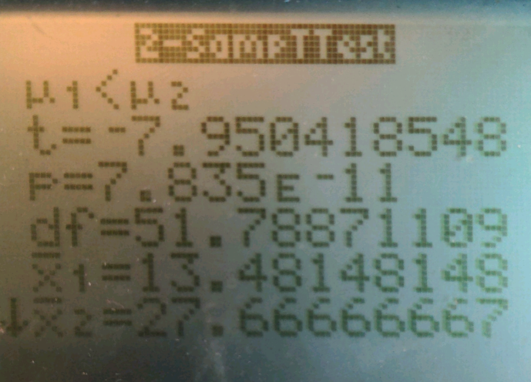
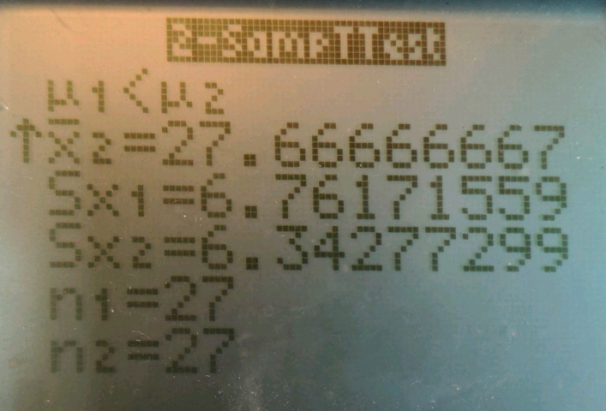

One-Sample T-Test
70% of 38 possible points is 26 points
Calculated mean percentage was 72.8%
P value is 0.0919167776

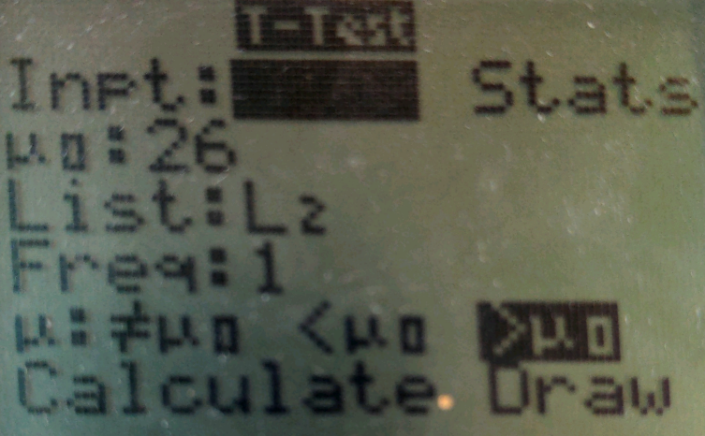
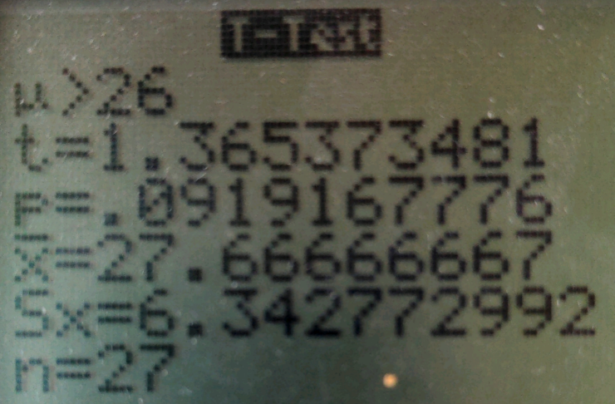

Test of Proportions
15 out of 27 students (55.5%) scored a 70% or above on the post-test
P-value is 0.999

